Tier 2 words
Year 6

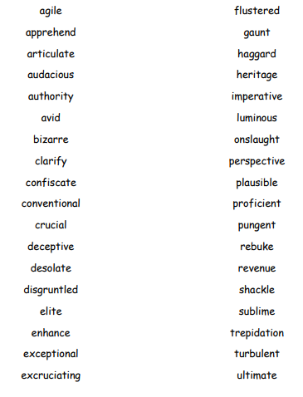

We have used all of these words since September. Can you use them in a bingo game with your families? Do you grownups know the definitions of these words? Test them and see.

