Topic work for the week commencing 8.6.2020
Art | Geography
How to draw a Spartan soldier:  https://www.youtube.com/watch?v=DNaGOcKWsy8  How to draw a Spartan helmet:  https://www.youtube.com/watch?v=tsA-3Tc86H4  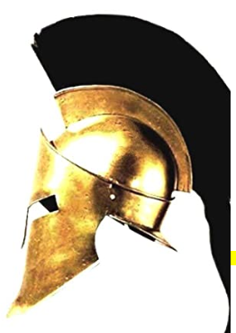  Can you use the links to draw a soldier or helmet? These are tricky and you will need to be patient! We can’t wait to see what you draw! | Where is Greece?  What continent is it in?  Does it border a sea?  What is the weather like there?  Use google earth to support your learning:  Or this link:  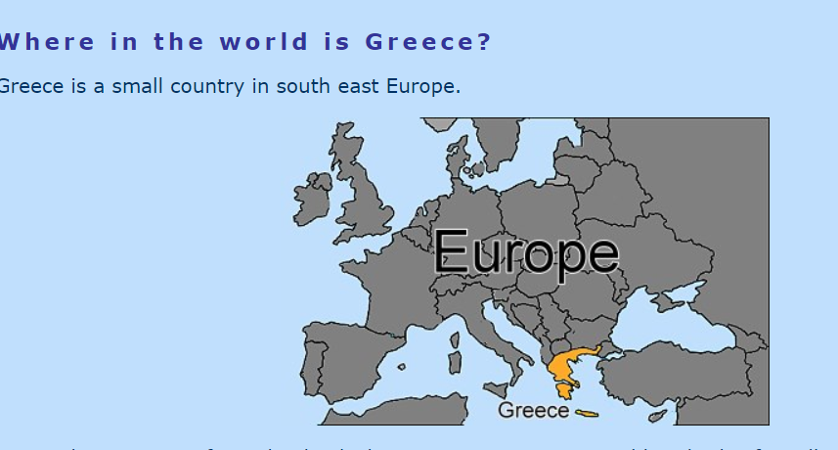  http://www.primaryhomeworkhelp.co.uk/greece/today.html  Can you do your own research and create a fact file explaining where Greece is? Remember to use key geography terminology (name the continent etc).  Print or draw maps to add extra detail!
Design technology
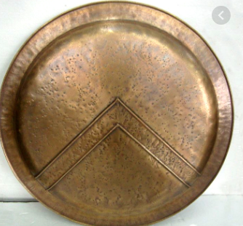
Can you create your own 3D Spartan shield?
What does your shield represent?
What design will you have on it?
Can you use cardboard and paper mache to make your own shield?
(This could be used as a prop for when you’re performing your Kenning
poem).

