Date:_____________________________
Content Domains: 2d/2b/2g
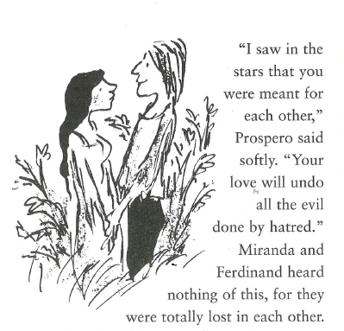
What are Prospero’s hopes and dreams for Miranda and Ferdinand?
___________________________________
___________________________________
___________________________________
How do we know that Miranda and Ferdinand were not listening?
___________________________________
___________________________________
Why were Miranda and Ferdinand not listening to Prospero?
___________________________________
___________________________________
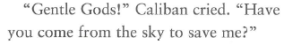
Why does Caliban call Trinculo and Stephano Gods?
_________________________________________
_________________________________________
_________________________________________
What does Caliban want Trinculo and Stephano to do?
_________________________________________
_________________________________________
_________________________________________
What does Caliban offer them for their help?
_________________________________________
_________________________________________
_________________________________________
