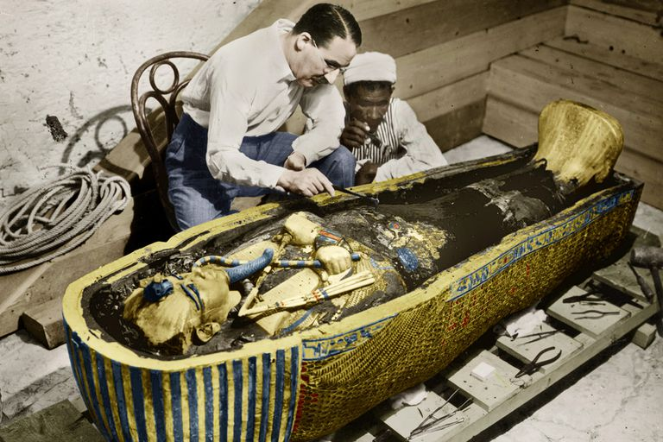

**Howard Carter stole from King Tutankhamun**

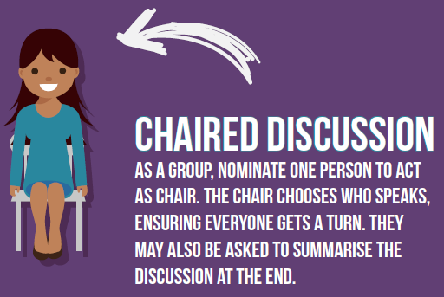

|  |  |
| --- | --- |
| **Agree** | **Disagree** |
|  |  |