Tuesday 16th June
This week we are going to be learning about Greek Myths! We are going to design and create our own Greek mythical creature and write our own non-chronological report about one.
Use this link to read mythical stories!
https://www.natgeokids.com/uk/discover/history/greece/greek-myths/

What are myths?
Created thousands of years ago, Greek myths were epic stories about Greek gods, passed down over generations. They often feature heroic battles and terrible creatures, and taught the importance of bravery, intelligence, and right and wrong. They showed that even the gods, like mortal men, could be punished or rewarded for their actions. Details of the ancient tales have been found on everything from pottery to temples to stone statues!

Using the pictures below write a detailed descriptive paragraph explaining what is happening in the picture.
Start at number 1, then follow the line to the next number. It will help you to describe each part of the picture in detail:
First make a plan for each number as seen below:
1: Children cowering
Shaking and frightened
Gasping in fear
2. Strong, muscular man
Powerful, Greek man
Cotton, white tunic wrapped
Lunging forwards
3. Razor sharp, silver sword
Sharpened, power weapon aimed towards
4. Mighty creature stepping backwards quickly
Half man, half bull
Then write in a descriptive paragraph. I have shown an example for number 1.

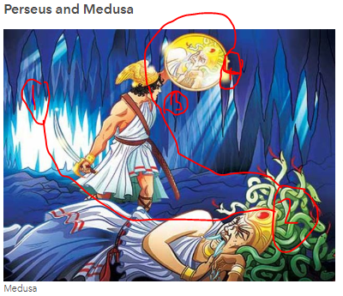
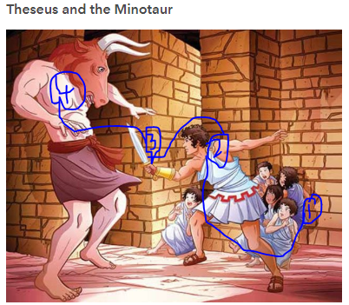
In the distance, the cowering, young children couldn’t take their eyes of what was happening in front of them. Lips trembling. Body shaking. Short, sharp breathes as they huddled against the terracotta, rough wall for their own safety.

Here is another picture if you would like to write another descriptive paragraph:

