Today, we are going to read pages 66-68, to start the Diagon Alley
Questions for pages 66-68
- Which phrase on page 66 suggests Harry was disappointed?
- Find and copy the phrase which suggests the owl was annoyed by Harry on p.67.
- Read the paragraph beginning, 'Yeah - so yeh'd be mad ter try…' on page 68.
For what reason does Hagrid believe Dumbledore asks him to do 'important stuff'?

Re-read pages 66 – 68, draw a key thought Harry had on each page.
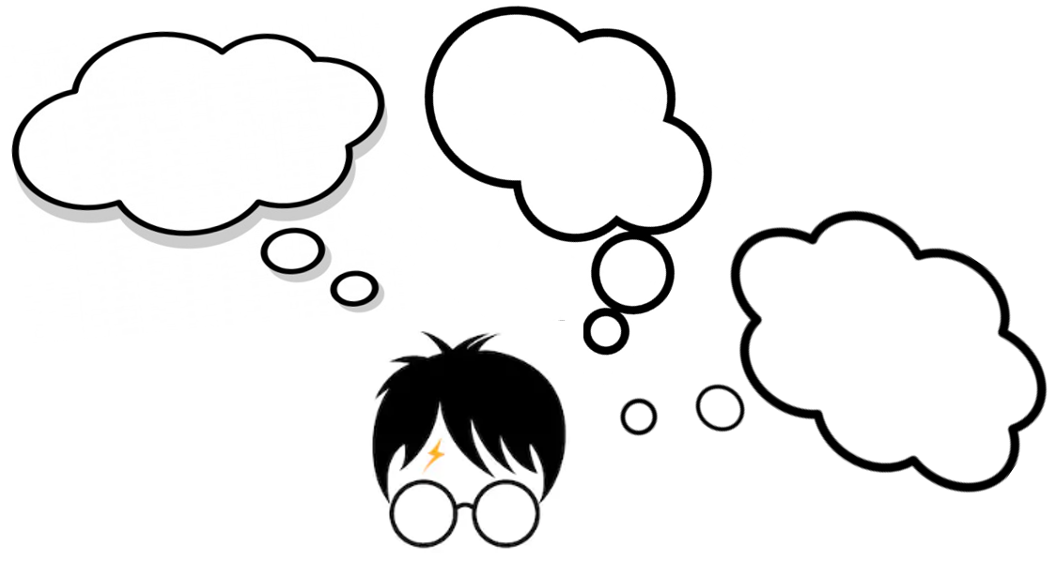
Then, explain what the thought was, and why it was important for Harry at that moment.

