Tuesday 30th June
Prediction

Look at the pictures below and make a prediction about our new text. Remember to give a reason for your prediction based on evidence in the picture. Remember to use modal verbs to show how certain you are of your prediction being correct.
Picture 1.
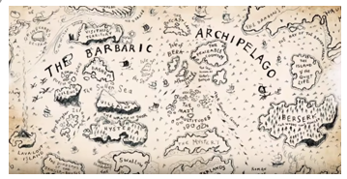
Example of what not to write for a prediction
I think that this is about an alien invading from space because I think that the aliens will land on Earth and take over the plant. The aliens might want to find out about humans and how they live.

This is not a good prediction because there is no evidence at all in the picture that that could happen. It is something that is completely in my head. I need to find clues in the picture to make me sure, that something could be true.
Your turn – write your predictions based on the pictures.
Picture 1 – above

Picture 2
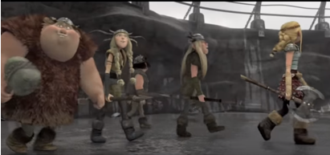

Picture 3
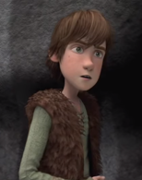

Picture 4
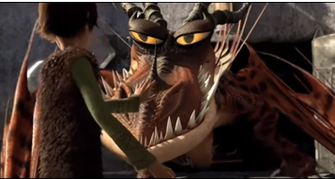

Picture 5
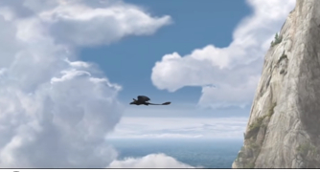

Now that you have seen all of the pictures and made your predictions, complete the probability scale below by inserting the statements onto the line to show how likely they are to happen.
