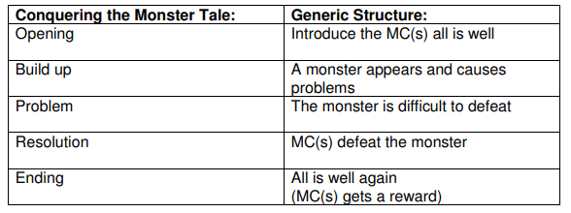
Tuesday 30th June 2020
This week we are writing a conquering the monster tale about the Greek creature which you designed last week.
Conquering the monster tale is the theme of our story which we will be writing.
Today can you start learning the Conquering the monster tale using talk for writing. (This is when you create your own actions to the story- we have done this MANY times so you know what to do!)

