Boy 87– Maths Activity 2

**(Interpreting bar charts, FDP, problem solving)**

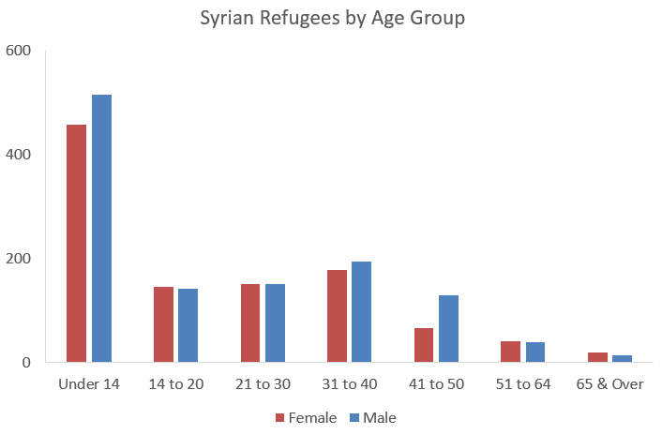

Per 100,000

Have a look at the bar graph – what does it tell us?

Look at the labels.

1. Tell me the story. Write a story for the graph like you did yesterday.
2. What do you notice about the age of refugees from Syria?
3. What do you notice about the gender of refugees from Syria?
4. In 2019, 5.6 million refugees fled from Syria. Approximately, how many children under the age of 14 was this?

**Extension activity** 🡪 Can you research and find out why the largest age group of refugees is those below 14 years old?