Questions for pages 79-81
- Find and copy the simile used to describe the rubies.
- What made Harry think the rattling cart knew where to go?
- Write two reasons that suggest Hagrid was telling the truth when he said he might be sick.
- How many Knuts are equal to one Sickle?
BONUS MATHS QUESTION – 3 Dojos for sharing the correct answer on Classroom or Dojo!
How many Knuts are equal to a Galleon?
- What happened as they sped around the tight bends?
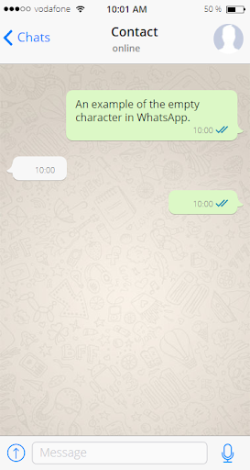
Now, imagine Harry sent a WhatsApp message to the Dursleys, letting them know that he was rich!

What do you think Uncle Vernon would reply?
Don’t worry, Uncle Vernon, I can pay for everything I need to go to Hogwarts!

