Tuesday 30th June 2020
Today, we are going to read pages 94-96 (Chapter six )
Questions for pages 94-96
- What did Harry have for company?
- Find and copy the verb which describes how Hedwig would fly into the open window?
- How did Uncle Vernon show he was listening?

Re-read pages 94 – 96, draw a key thought Harry had on each page.
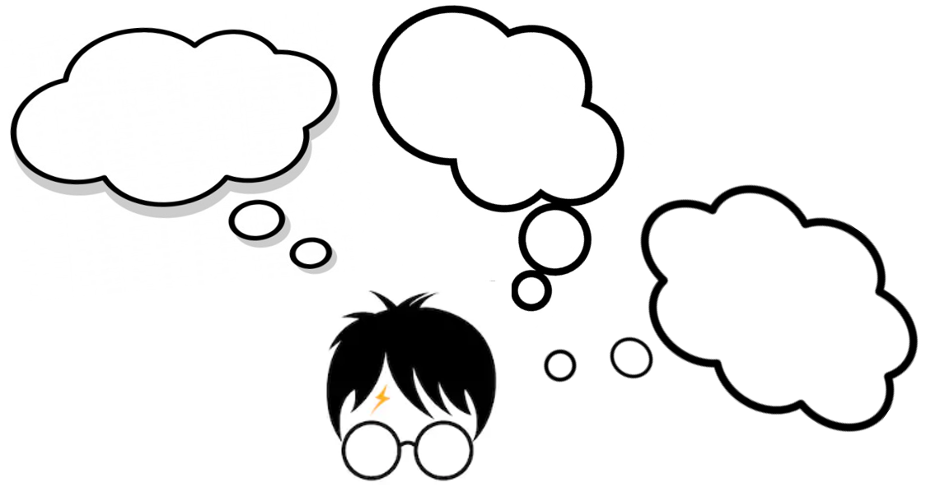
Then, explain what the thought was, and why it was important for Harry at that moment.

