Tuesday 30th June 2020
- 26 x 3
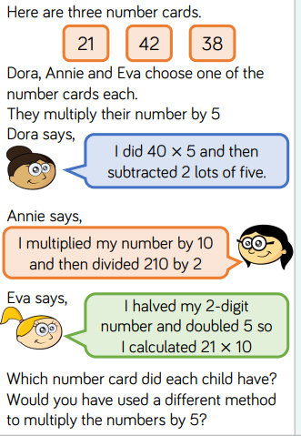
- 52 x 4
- 86 x 9 =
- 112 x 5 =
- 162 x 7 =
- 271 x 8 =

