https://www.bbc.co.uk/bitesize/topics/zsq7hyc

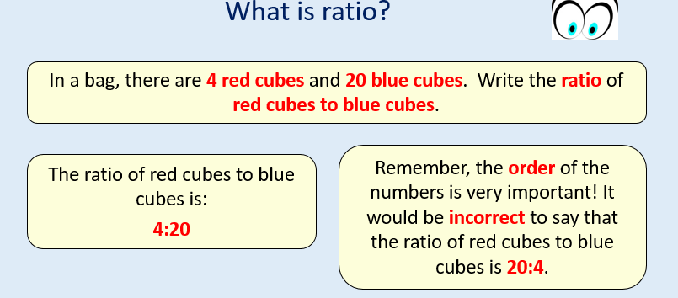
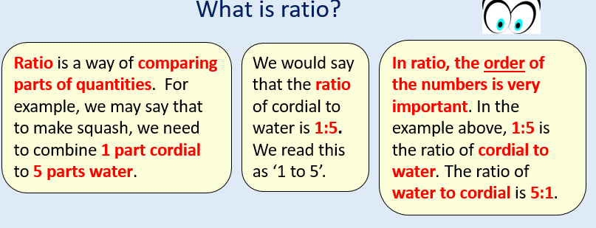
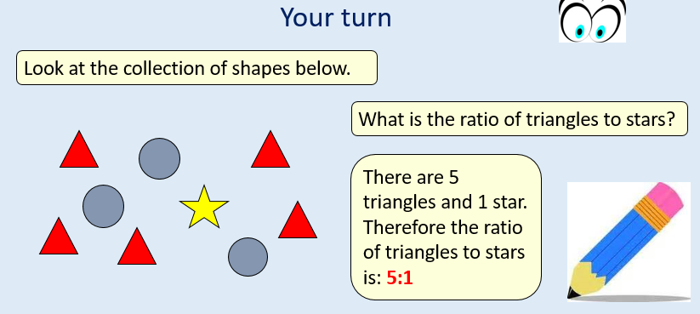

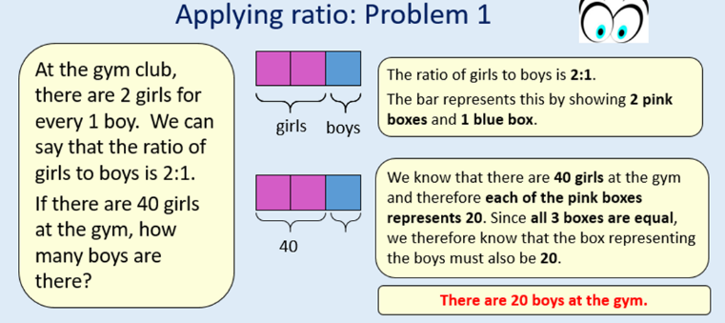
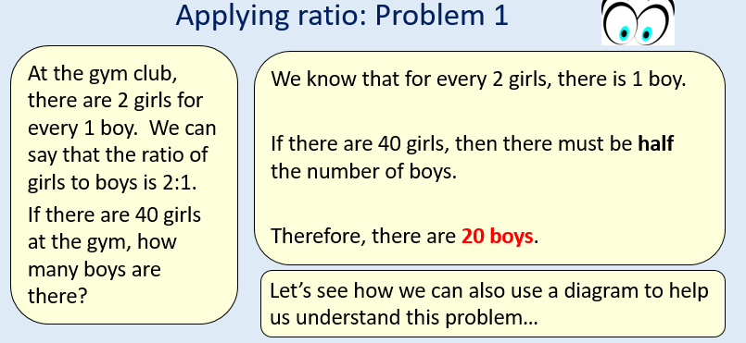

Please sure the power point on the website if you need any further help.
Tuesday
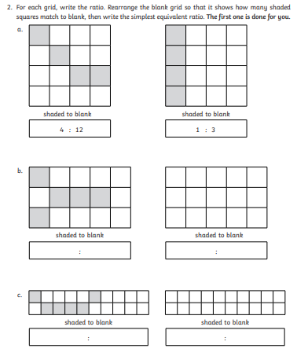
- For the shapes below, write down the ratio of blue to red counters.

- In a class of 30 pupils, 12 are girls. What is the ratio of boys to girls in the class? Can you draw an image to represent this?

- In a recipe for 2 people you need 120g of flour. How much flour would I require to make the same recipe for 5 people?

- 28 pupils are going on a trip. They are in a ratio of three girls to four boys. How many boys are there?

