Tuesday 9th June
English – Xfilious

Read the WAGOLL poem – Xfilious
The poem describes a dragon step by step, analysing every detail of its body.
Look for the following words or phrases in the poem, read around them and write down what you think they mean.
Example
pitch - I know that a pitch is an area of ground marked out or used for playing on or that pitch can refer to sound. Does that fit with the poem and what pitch could mean in the poem?
If I read the first verse, it says, “Its Scarlet eyes scan the pitch undergrowth…” So pitch could be describing the undergrowth. Pitch black means dark, so the author could be describing the undergrowth as dark.
What do you think these words mean and what made you think that?
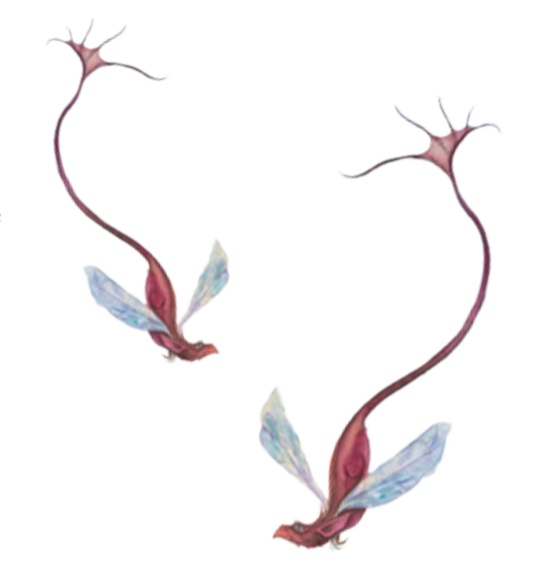
- possessed
- grinding
- drizzling
- glistening
- menacingly
- scalpel
- monstrous

