Who was Tutankhamun?

https://www.bbc.co.uk/bitesize/articles/zr2tnrd

Pharaohs were the kings of Ancient Egypt. They ruled over the land, collected taxes from the people, enforced the law and led the Egyptian army against invaders.

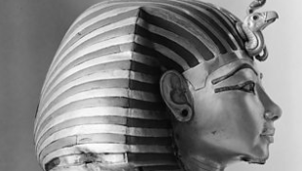
Tutankhamun reigned for roughly ten years. He died around the age of 18 and was buried in a tomb in the Valley of the Kings.
His burial place was hidden for many centuries. The Egyptologist Howard Carter discovered it in 1922. It contained many amazing artefacts, including Tutankhamun’s famous golden death mask, a chariot and a dagger made from meteorite iron!

Watch the clip below to learn how Tutankhamun’s tomb was discovered.
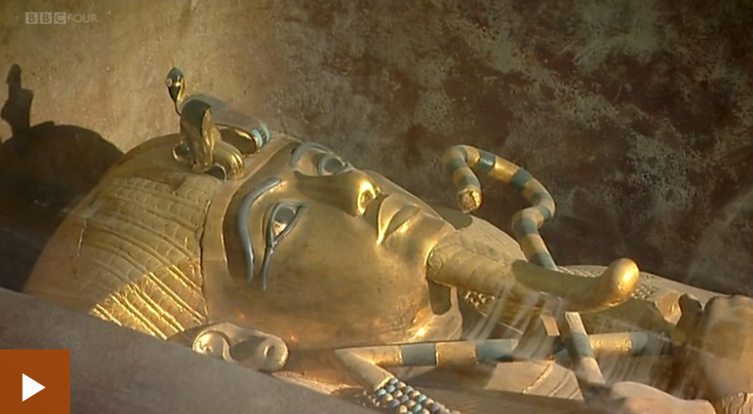
Now can you create your own timeline about 5 of the great Pharaohs? Use bbc bitesize or dkfind out.

Create a dairy entry of Howard Carter. Go back and use the previous wagoll. Remember to use your year 6 tool box.

