DT – Design a Viking meal

What did the Vikings eat?
Carry out some research to find out what the Vikings would eat.
Write a paragraph about the different foods that they ate and why they ate those foods.
The following websites will help you with your research:
https://www.bbc.co.uk/bitesize/clips/z4pnvcw#:~:text=Vikings%20ate%20fruit%20and%20vegetables,tools%20for%20hand%20grinding%20grain.
http://www.primaryhomeworkhelp.co.uk/viking/food.html
https://www.fotevikensmuseum.se/d/en/vikingar/hur/mat/recept

Design a meal for your family that the Vikings could have made during their time.
Draw the meal and label the ingredients that the Vikings would have had to make it.

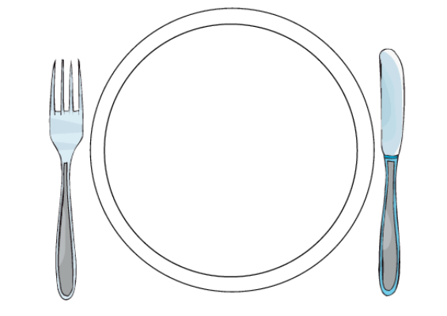
If you can get hold of the ingredients for this meal, you can make it as part of your DT work next week!

