Wednesday 10th June
Adding three fractions with different denominators
re-cap – equivalent fractions
Have a go at completing these sequences to see what you can remember about equivalent fractions.
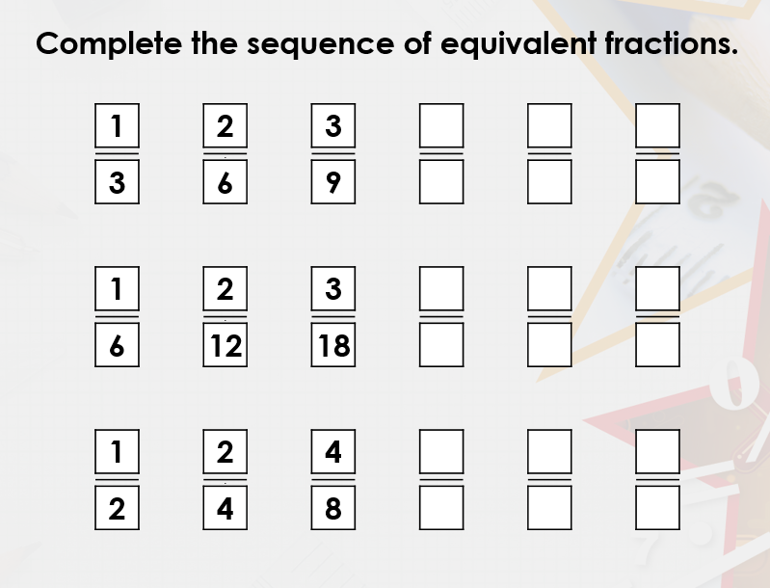
How do we add three fractions with different denominators?
$$\frac{1}{5}+\frac{3}{10}+\frac{2}{20}=$$

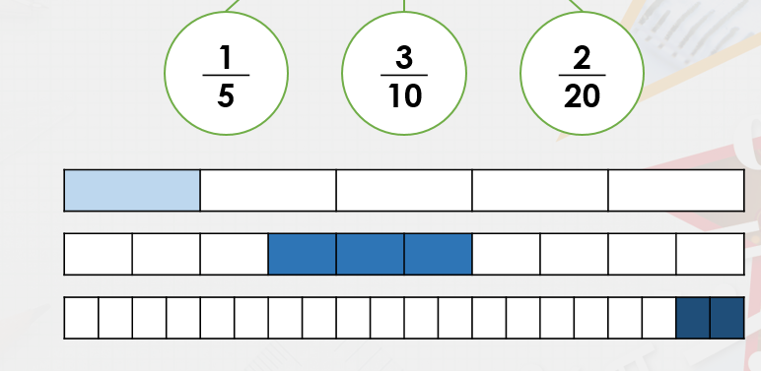
Here is the link to a video to explain how we do it https://www.loom.com/share/a456958658524280a0df196154f01927

Find the common multiple/ common denominator.
20 is a multiple of 5, 10 and 20, so we use 20ths as our denominator.
$$\frac{1}{5}=$$
To convert 5ths into 20ths, we multiply the denominator and the numerator by 4.
$$\frac{1}{5}=\frac{4}{20}$$

To convert $\frac{3}{10}$ into 20ths, we multiply the numerator and denominator by 2.
$$\frac{3}{10}=\frac{6}{20}$$

Now all three fractions are in 20ths, we can add them together.
$$\frac{4}{20}+\frac{6}{20}+\frac{2}{20}=\frac{12}{20}$$
(This can be simplified to $\frac{3}{5}$)

Your Turn – add these fractions
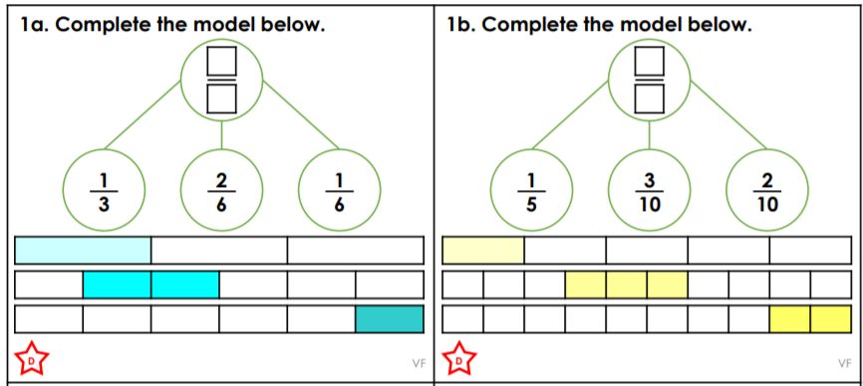
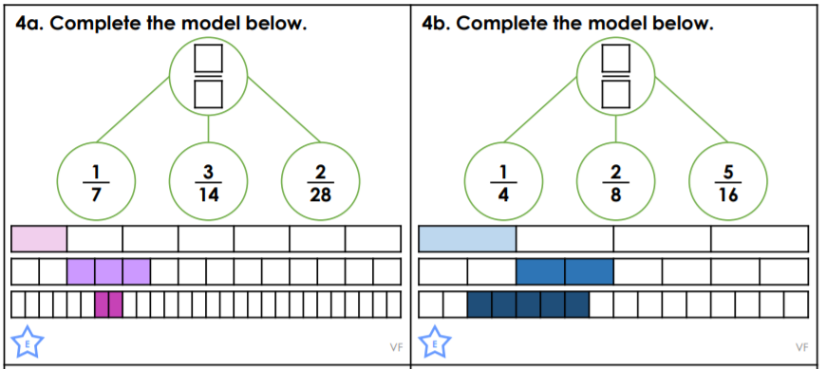
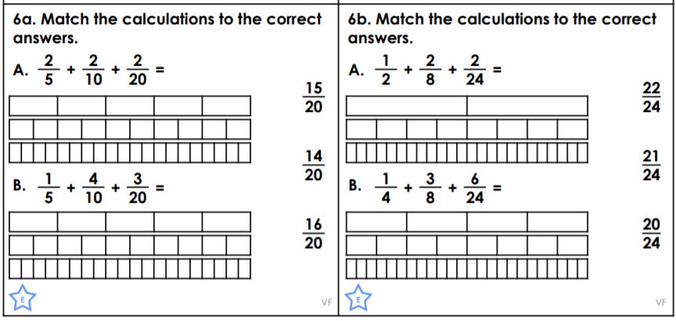

Challenge
