Wednesday 17th June 2020
Following on from your descriptive writing yesterday can you please research about Greek Myths and the gods and creatures which were involved in the stories! Create a mind map of what you have found out!
There was a link yesterday, here it is again.
https://www.natgeokids.com/uk/discover/history/greece/greek-myths/
https://greece.mrdonn.org/theseus.html
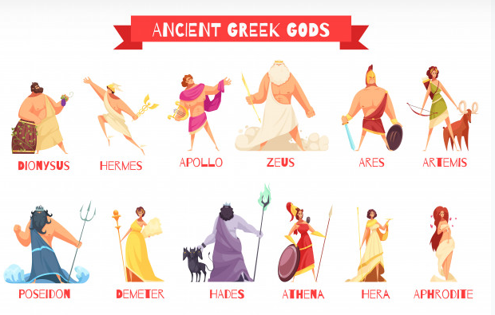
https://greece.mrdonn.org/zeus.html

