Wednesday 17th June
Subtracting fractions
Find the difference mean subtract.
How do we subtract fractions with different denominators?
e.g.
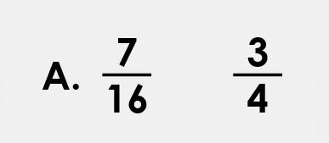 convert $\frac{3}{4}$ into 16ths.
multiply the numerator and the denominator by 4.
$$\frac{3}{4}=\frac{12}{16}$$
To find the difference between $\frac{7}{16}and\frac{12}{16},$ we subtract the smallest fraction from the greatest fraction.
12 – 7 = 5 so the difference is $\frac{5}{12}$

Your turn
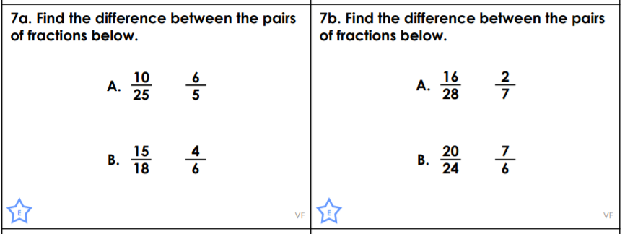

What happens when the denominators are not multiples of each other?
How do we find the difference between these fractions?
Follow this link for a video explanation!
https://www.loom.com/share/4732ffc3b45545ff8543725064691c12

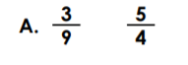
We need to find a common denominator – a number that is a multiple of both denominators.
Make a list of multiples of 9 and multiples of 4. The first number that is the same in both lists is the lowest common denominator.

9, 18, 27, 36, 45, 54,63, 72, 81, 90
4, 8, 12, 16, 20, 24, 28, 32, 36, 40

36 is the common denominator, we have to convert both fractions into 36ths.

$\frac{3}{9}=\frac{12}{36}$ $\frac{5}{4}=\frac{45}{36}$
45 – 12 = 33 so the difference between the fractions is $\frac{33}{36}$

Your Turn
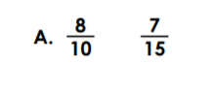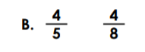

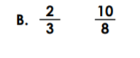

Challenge
