Wednesday 1st July
Converting measures

What can you remember about converting kg to g and km to m?
Are these statements true or false? Prove it
Statement | True | False | Prove it
3.5kg = 350g
2300m = 230km
2.6km = 2600m
2750g = 2.75kg

Have a look at the question below – How could we work out if they all ran the same distance? Convert the three measures so that they are in metres. Are they all the same?
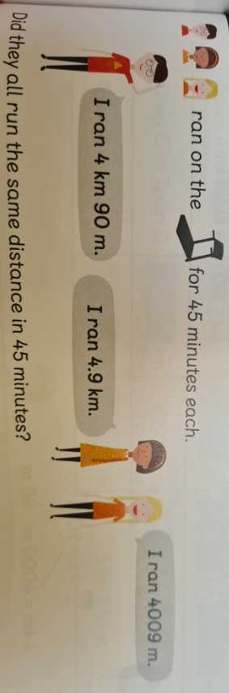

Now try to copy and complete the table
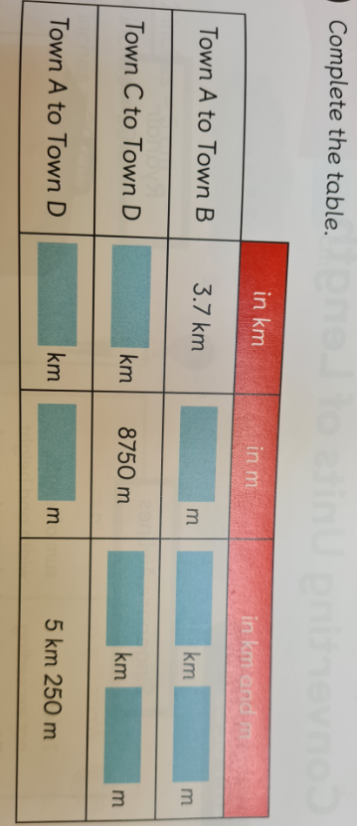
Now try these using the same methods for converting measures
(divide by 1000 to convert g to kg)
