Wednesday 20th June
Direct and Reported Speech

What is the difference between direct and reported speech?
Direct speech
Direct speech is a sentence in which the exact words spoken are reproduced in speech marks (also known as quotation marks or inverted commas).
E.g. (from the WAGOLL)
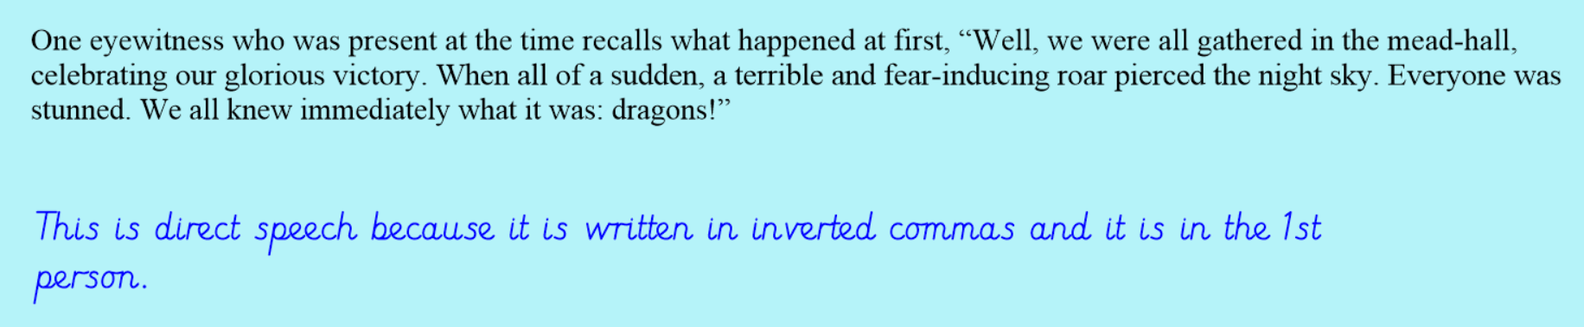
How do you punctuate direct speech properly?
Watch this video on how to punctuate direct speech, then have a go at punctuating the following speech sentences accurately.
https://www.bbc.co.uk/bitesize/topics/zr6bxyc/articles/zhqh92p

Your Turn – punctate these sentences accurately with speech punctuation.
- Jane said the dragons came flying down from the sky and started to attack me so I had to flee for cover.
- It was terrifying and I panicked stated Shane.
- I couldn’t believe my eyes when Hiccup began to fight the dragons. he is my hero reported Helen admiringly.
- One witness said I was so relieved when it was all over and Hiccup had saved the day.
- When Hiccup defeated the dragon reported Fred every agreed that he needed a huge reward.

So what is Reported/ Indirect Speech and how is it different to direct speech?
When indirect speech is used, the writer will share the main points of what someone has said without writing exactly what they said in full.
No speech punctuation (eg inverted commas) is used for indirect speech.
E.g. (from the WAGOLL)

- Verb tenses usually shift back a tense (into the past)
- Word order often needs to change
- Pronouns often need to change
- Words indicating place and time need to change

Example of changing direct speech to reported/ indirect speech

“I could hear the battle raging all around and it was terrifying!” Hiccup recalls. (direct speech)
Hiccup recalls that he could hear the battle raging all around and it was terrifying. (reported speech)

Your Turn – look back at the direct speech sentences that you punctuated earlier. Have a go at changing them into indirect/ reported speech.

