Wednesday 24th June 2020
English

Tenses
Newspaper articles report on something that has already happened. Therefore, it is important that the verbs you use are in the correct tense.

What is past perfect tense?
The past perfect, is a verb tense used to discuss actions that were completed before a specified (or implied) point in the past.
The past perfect tense is usually formed by combining the past tense of 'had' with the past participle of the verb used e.g. 'I bake' in the present tense becomes 'I had baked' when you use the past perfect tense.
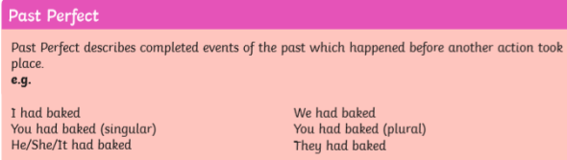

What is past perfect continuous?
Past perfect continuous or past perfect progressive can be used in the same way, but indicates that something began in the past and has since ended.
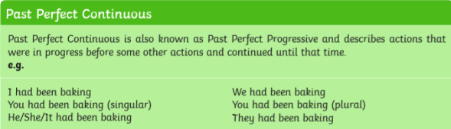

Watch the following clip to help you more with past tense:
https://www.youtube.com/watch?v=sKJTw4t2dVM

- Re-read your work from yesterday and check your verb tenses are in past tense.
- Continue the next detailed section of your newspaper report. You need to include another witness to explain what happened to them/what they saw. Try and use the opposite speech to yesterday’s.
E.g. if yesterday you used direct speech, try use reported speech today.

