Wednesday 24th June
The Wider World – prediction

Look at the next Chapter Title. What do you think you will find out about in the this chapter? Give reasons for your answer.
Remember to include modal verbs to show how certain you are in your prediction and to use conjunctions to link your ideas/ reasons.
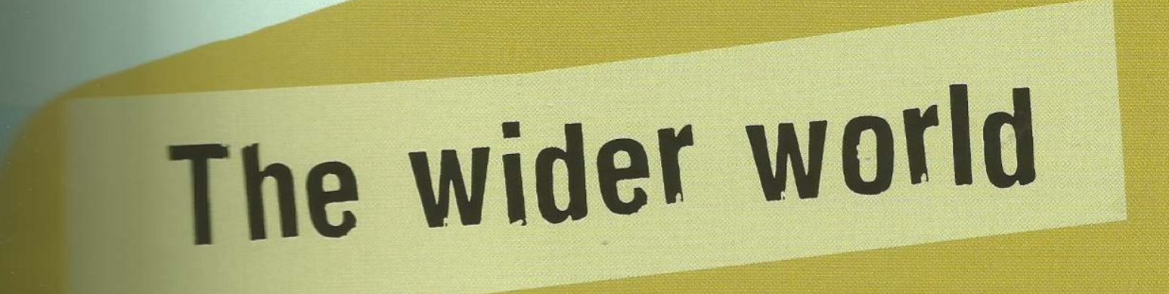
Prediction:

Now read the chapter introduction below.
What impact has this had on your prediction? What do you predict you will find out about now?
Add to your prediction and give reasons why you have changed your thoughts or why this confirms your original thoughts. Remember to use the evidence in the text in your prediction.

