Wednesday 24th June
Adding mixed numbers – varied fluency

Now that you know how to add mixed numbers, we are going to apply it to different contexts.
Re-cap from yesterday – have a go at this one.
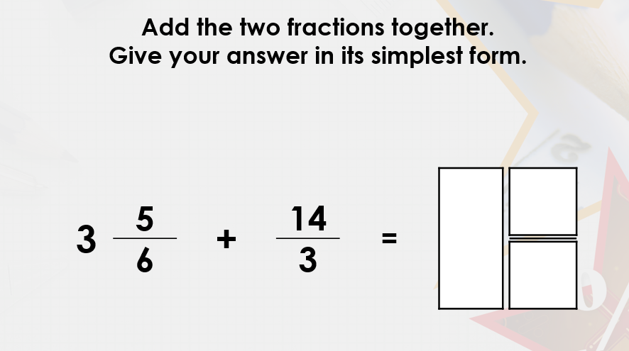 +
Now to apply this to different situations and fluency questions.
Example
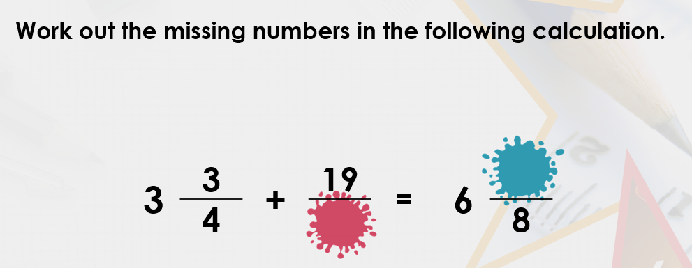

There is a clue in the answer as the denominator is in 8ths. This suggests that’s the missing denominator could be 8. Let’s try it and see if that helps us to work out the missing numerator in the answer.
3$\frac{3}{4}$ + $\frac{19}{8}=$
Convert the 4ths (quarters) into 8ths and the improper fraction into a mixed number.
3$\frac{6}{8}+$2$\frac{3}{8}=$

Ignore the wholes for now and add the fractions: $\frac{6}{8}+\frac{3}{8}=\frac{9}{8}$= 1$\frac{1}{8}$
Now add the whole back on: 3 + 2 + 1$\frac{1}{8}=$6$\frac{1}{8}$

For this example and another, see the loom video:
https://www.loom.com/share/523f231c189148af901c0ec10f3ee880

Your turn – have a go at these fluency and reasoning questions
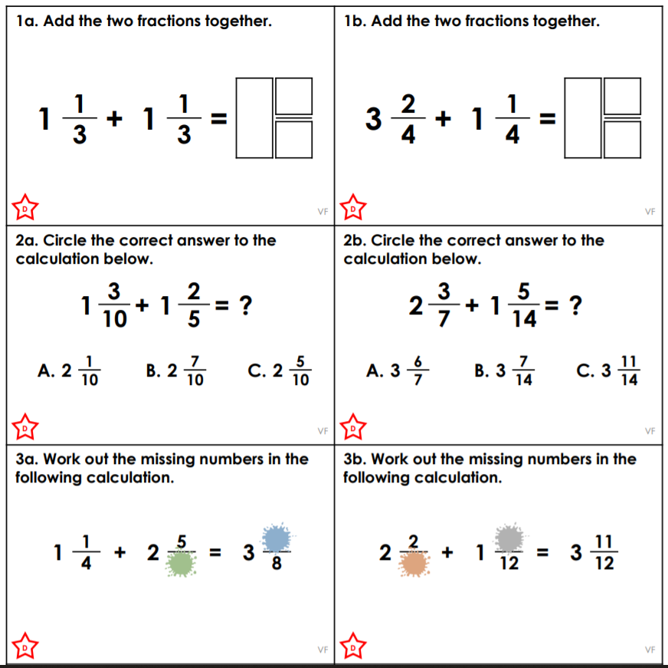

Challenge
