Questions for pages 81-83
- Why did something really extraordinary have to inside the to-security vault?
- Find the verb which describes how they were stood in the sunlight. (pg 82)
- What was the boy’s voice described as?

Below is a statement linked to the pages we have read.
Think about the evidence you can think of to agree and disagree with it. Share your ideas with the adults – we would love to see your ideas written down, in voice or video recordings!

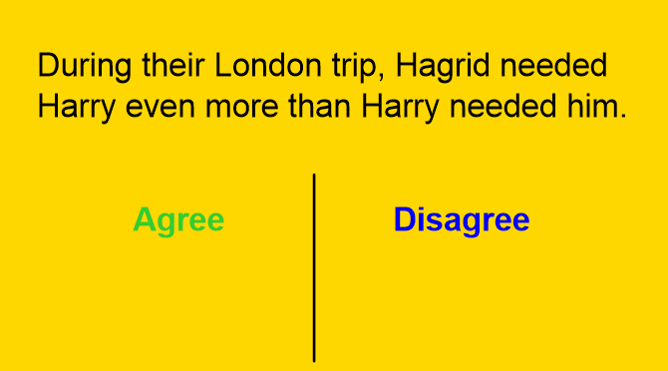
Do you think the boy was as worse as Dudley or worse?

