Questions for pages 97-99
- Why do you think that Uncle Vernon had an even nastier smile?
- Find and copy the verb which describes how the 3rd boy walked to the ticket barrier?.
- How was the youngest boy described?

Below is a statement linked to the pages we have read.
Think about the evidence you can think of to agree and disagree with it. Share your ideas with the adults – we would love to see your ideas written down, in voice or video recordings!

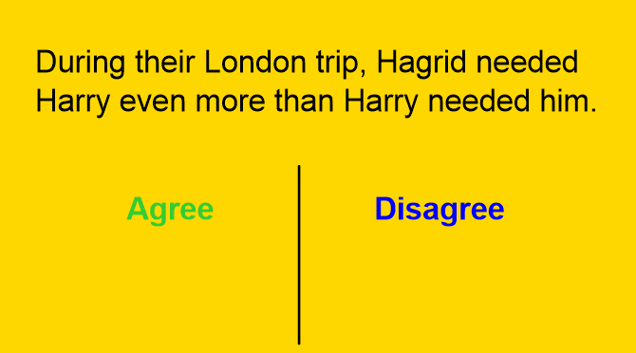
Uncle Vernon should have helped Harry wen trying find Platform 9 ¾

[Grab your reader’s attention with a great quote from the document or use this space to emphasize a key point. To place this text box anywhere on the page, just drag it.]

