Wednesday 1st July 2020
Reading
Why did the Viking Age come to an end?

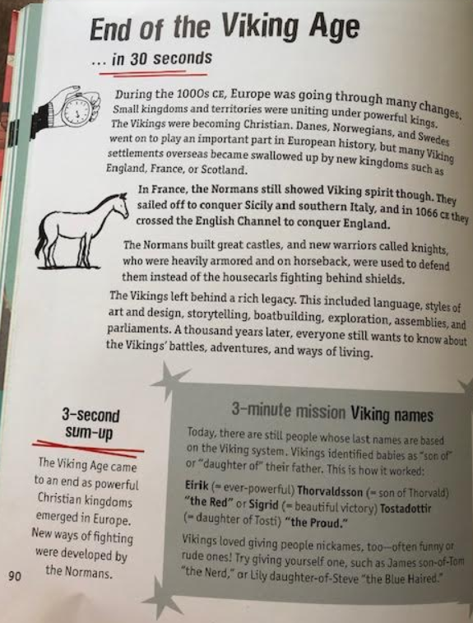
Find and copy two things that the Vikings ‘left behind’.

What Viking name would you give yourself?

Why do you think the Normans would have been more successful fighters than the Vikings?

