https://www.bbc.co.uk/bitesize/topics/zsq7hyc

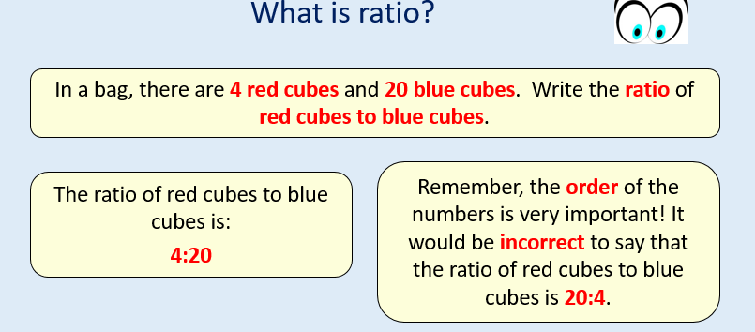
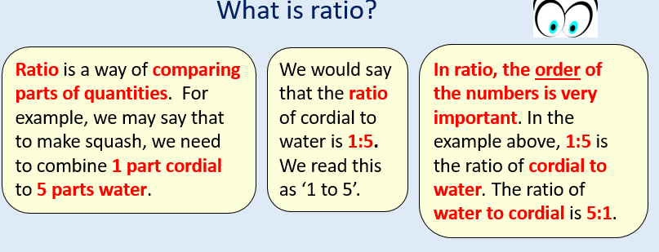
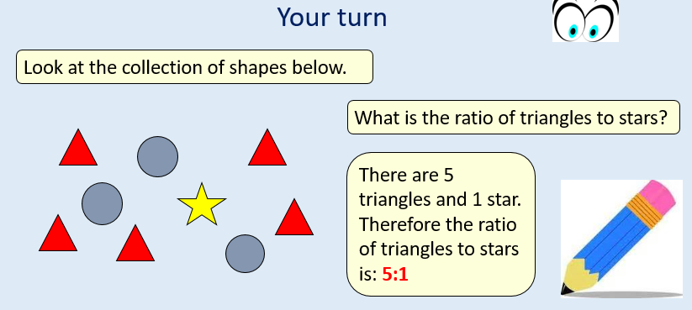

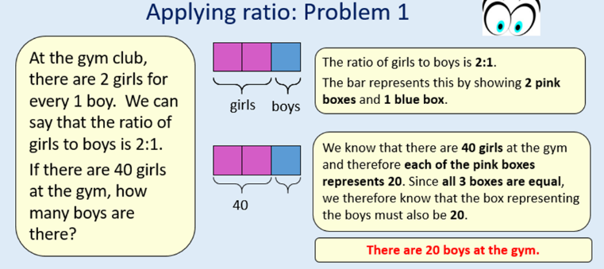
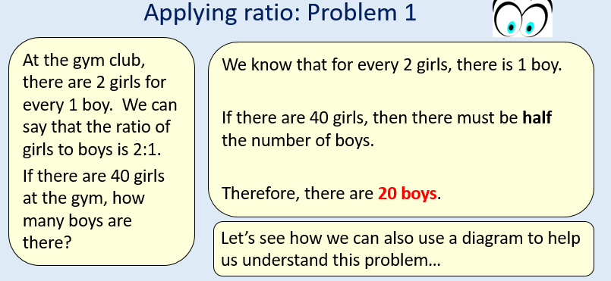

Please sure the power point on the website if you need any further help.
Wednesday
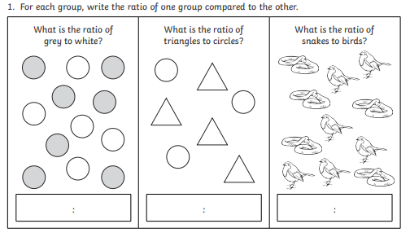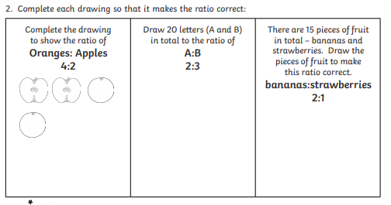
- A shade of pink is made by mixing 2 parts red paint to 5 parts white paint. What is the ratio of red to white paint?

- Of a team of 10 people, 3 are male. What is the ratio of males to females in the team?

- I make squash by mixing 1 part cordial with 5 parts water. I want to make a large jug of squash. If I use 3 cups of cordial how many cups of water would I need?

- A mother seal is fed 5 fish for every 2 fish for its baby. The zoo keeper feeds the seals 35 fish. How many does the baby seal get?

