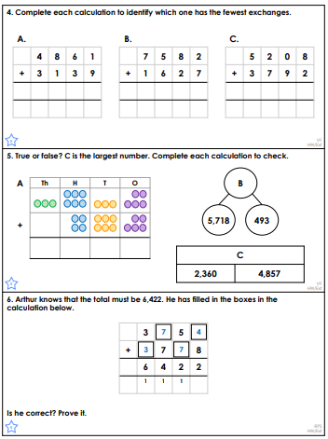**Adding two 4 digit numbers**

Ashley has 281 balls.

On Monday he bought 762 balls.

On Tuesday he bought another 3841 balls.

How many balls does Ashley have now?

Which one is the odd one out?

1. 5638 + 3872 = 9510
2. 2214 + 3548 = 5762
3. 792 + 2371 = 3167
4. 2003 + 1563 = 3566