L.I:-To be able to use retrieval and inference skills to answer questions.
PG 17 – 40
How do you know that Mum is scared?
_____________________________________________________________________________________________________________________________________________________________________________________________________________________________________________________________________________________________
Why can’t Bini go to school?
______________________________________________________________________________________________________________________________________________________________________________________________
What is your impression about this?
____________________________________________________________________________________________________________________________________________________________________________________________________________________________________________________________________________________________________________________________________________________________________________________________
Why will they finish school early?
_______________________________________________________________________________________________

Where do youngsters go for school for two years after leaving school?
_______________________________________________________________________________________________

Why has the author used “like a flame on paper”? What is the effect?
_____________________________________________________________________________________________________________________________________________________________________________________________________________________________________________________________________________________________
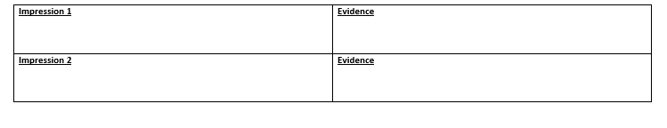
What is the impression of the army in the country? Use evidence from the text.

What has Shif found out?
_____________________________________________________________________________________________________________________________________________________________________________________________________________________________________________________________________________________________

Write a diary entry as though you are Shif. Use the evidence from the text to support your writing.
_________________________________________________________________________________________________________________________________________________________________________________________________________________________________________________________________________________________________________________________________________________________________________________________________________________________________________________________________________________________________________________________________________________________________________________________________________________________________________________________________________________________________________________________________________________________________________________________________________________________________________________________________________________________________________________________________________________________________________________________________________________________________________________________________________________________________________________________________________________________________________________________________________________________________________________________________________________________________________________________________________________________________________________________________________________________________________________________________________________

