Monday 29th June 2020
English

LI: - drawing inferences on characters’ feelings, thoughts and motives from their actions.

What does the front cover of the book tell you?
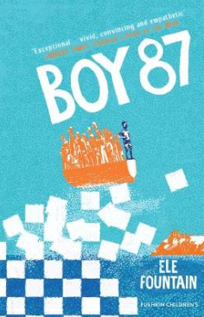
Annotate your ideas around the book. An example has been done for you.
There may be other boys before/after him. Who are they?

Role on the wall. What characteristics would these boys need to survive this situation?

Short burst writing - Diary Entry
We don't know much about the characters or plot yet but use the information you have been given to write a short diary entry.
- What was it like leaving your family?
- What was the desert prison like?

