L.I:- To be able to make a justified prediction by using evidence from the text.
Make a prediction as to what you think the book is about. Use evidence from the front cover.
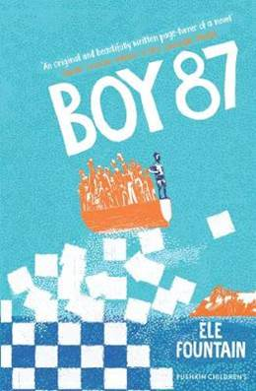
___________________________________________________________________________________________________________________________________________________________________________________________________________________________________________________________________________________________________________________________________________________________________________________________________________________________________________________________________________________________________________________________________________________________________________________________________________________________________________________________________
Fourteen-year-old Shif and his best friend Bini are ordinary boys with big ambitions, but their world implodes when they attract the attention of the military "giffa". Wrenched from their families, they’re sent to a remote desert prison, where their cellmates are barely clinging to live.
However, the boys’ arrival sparks hope in the imprisoned men, and they give everything to ensure their escape. Reaching the nearest town, Shif has only just begun the perilous journey which he hopes will end in safety and freedom.
Set in an unnamed country, this is a timely and important book which illuminates the realities of life as a refugee. The first-person narration simply but powerfully conveys Shif’s terror at the violence and cruelty he encounters, as well as his sense of loss. The horrors he is escaping are all too real, but this is ultimately a story about the power of kindness and the strength of the human spirit.
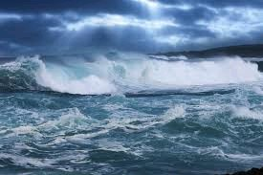
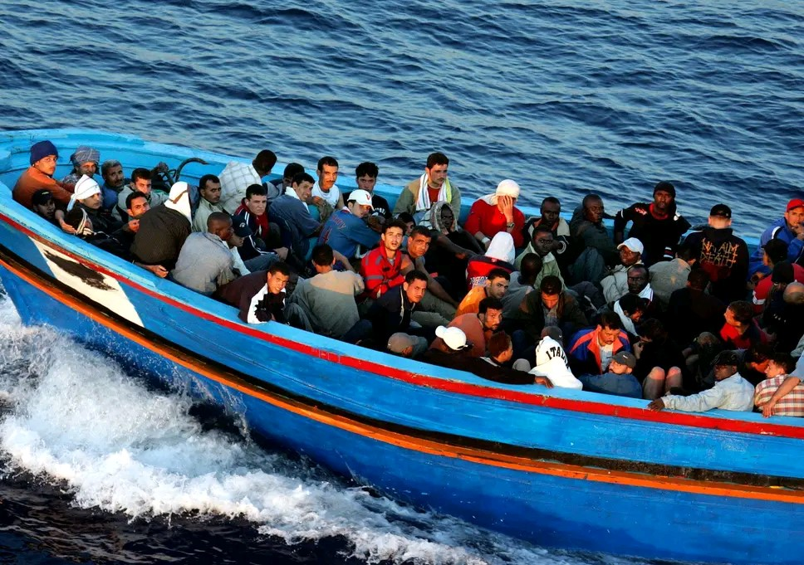

What may be the significance of these images?
___________________________________________________________________________________________________________________________________________________________________________________________________________________________________________________________________________________________________________________________________________________________________________________________
Word | Class | Meaning
Swell
Instinct
Numb
Urge

What may the phrase “Boy 87” mean? _____________________________________________________________________________________________________________________________________________________________________________________________________________________________________________________________________________________________

