Pg 7 - 15
Statements | True/ False | Evidence from the text
Bini is not as clever.
They are wealthy.
The main character wants to be a doctor.
All the children go to school.
At school, they wear uniforms.

Explain the significance of the chess set. Pg 11
_____________________________________________________________________________________________________________________________________________________________________________________________________________________________________________________________________________________________
Describe their relationship using evidence from the text.
____________________________________________________________________________________________________________________________________________________________________________________________________________________________________________________________________________________________________________________________________________________________________________________________
What suggests that the army are dangerous?
___________________________________________________________________________________________________________________________________________________________________________________________________________________________________________________________________________________________________________________________________________________________________________________________________________________________________________________________________________________________
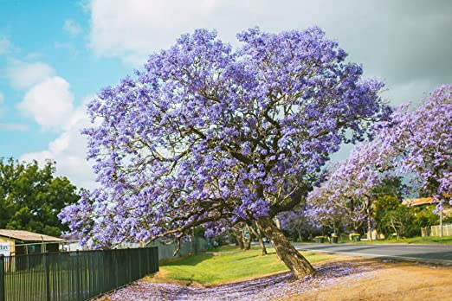
What evidence is there that the story is not set in England?

Why are the boys so shocked that Kidane had spoken about their Fathers?
____________________________________________________________________________________________________________________________________________________________________________________________________________________________________________________________________________________________________________________________________________________________________________________________
What do I know for certain? | What do I think? | What do I wonder?

