Images | Describe what you see and the emotions it gives to you.
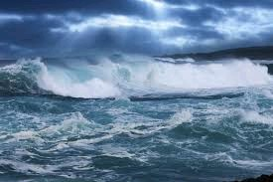
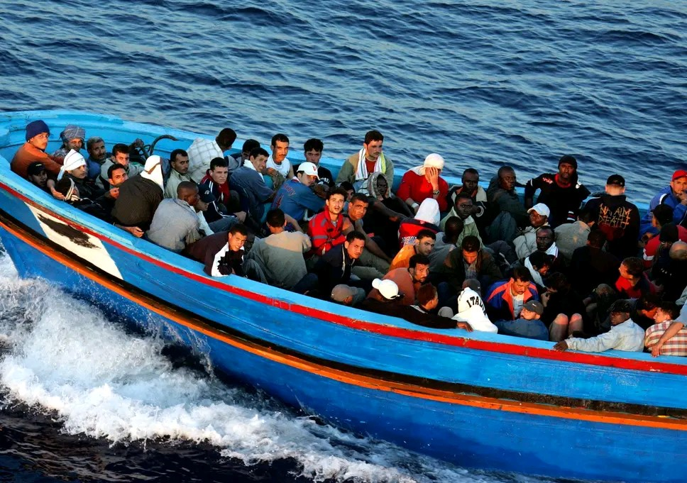
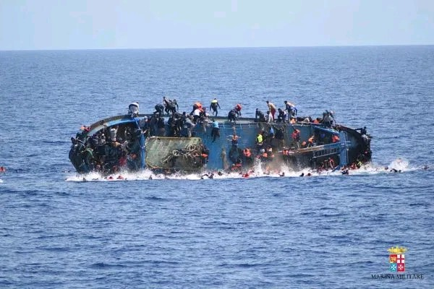

Where is the character?
_____________________________________________________________________________________
Will the sea subside?
_____________________________________________________________________________________
Why are they in the boat?
______________________________________________________________________________________________________________________________________________________________________
Will they survive? Give evidence from the text. _______________________________________________________________________________________________________________________________________________________________________________________________________________________________________________________________
Why are they there?
__________________________________________________________________________________________________________________________________________________________________________
Where are they headed?
_____________________________________________________________________________________

What might he find to help him survive?
____________________________________________________________________________________

What does the plastic bag provide?________________________________________________________

In the text, the wind and waves are threatening and violent. Find examples in the text to show this.
________________________________________________________________________________________________________________________________________________________________________________________________________________________________________________________________________________________________________________________________________________________________________________________________________________________________________________________________________________________________________________________________________________________________________________________________________________________________________________________________________________________

Will Shif survive?
Yes/no/maybe
Yes | No

