Geography – Viking or Anglo-Saxon place names
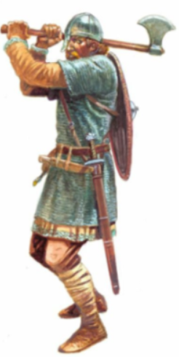

Re-cap – Quiz – What can you remember about the Vikings and Anglo-Saxons?

- Which countries did the Anglo-Saxons come from?
- Which 3 groups of people made up the Anglo-Saxons?
- Why did the Anglo-Saxons invade Britain?
- How do we know that the Anglo-Saxons were here in Britain? What evidence is there?
- Which countries did the Vikings come from?
- Why did the Vikings raid Britain?

Anglo-Saxon and Viking Place Names in Britain
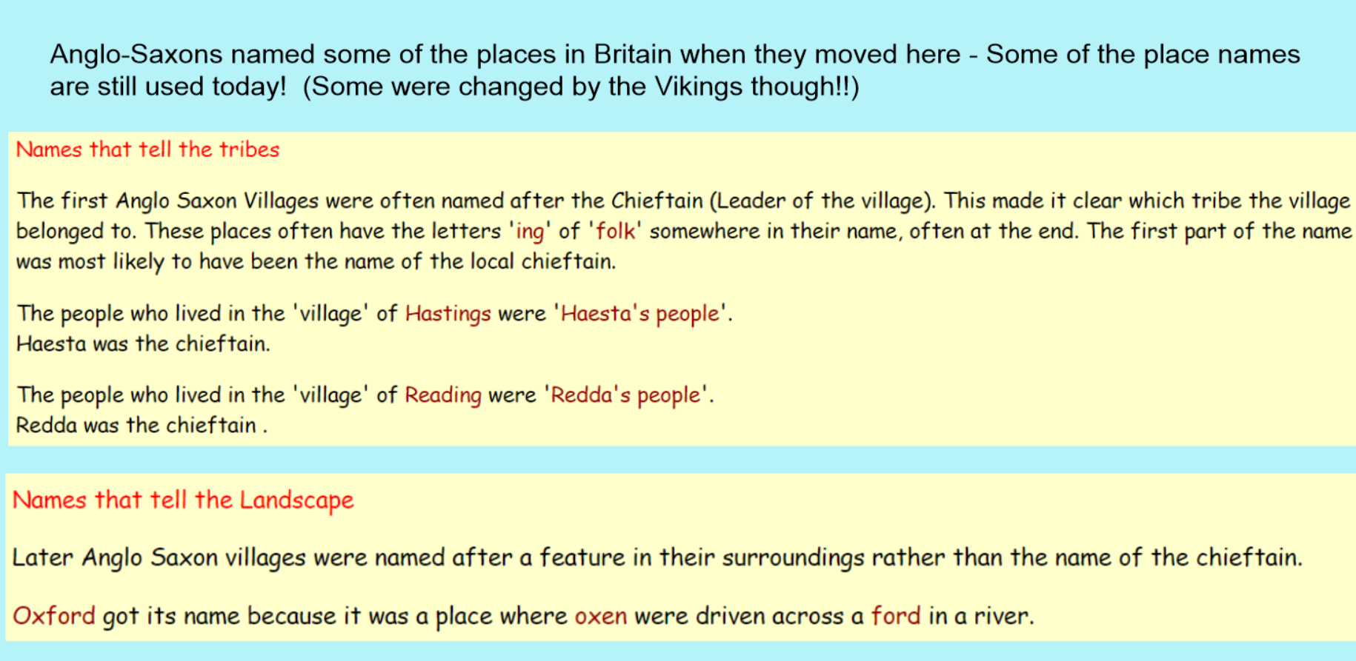
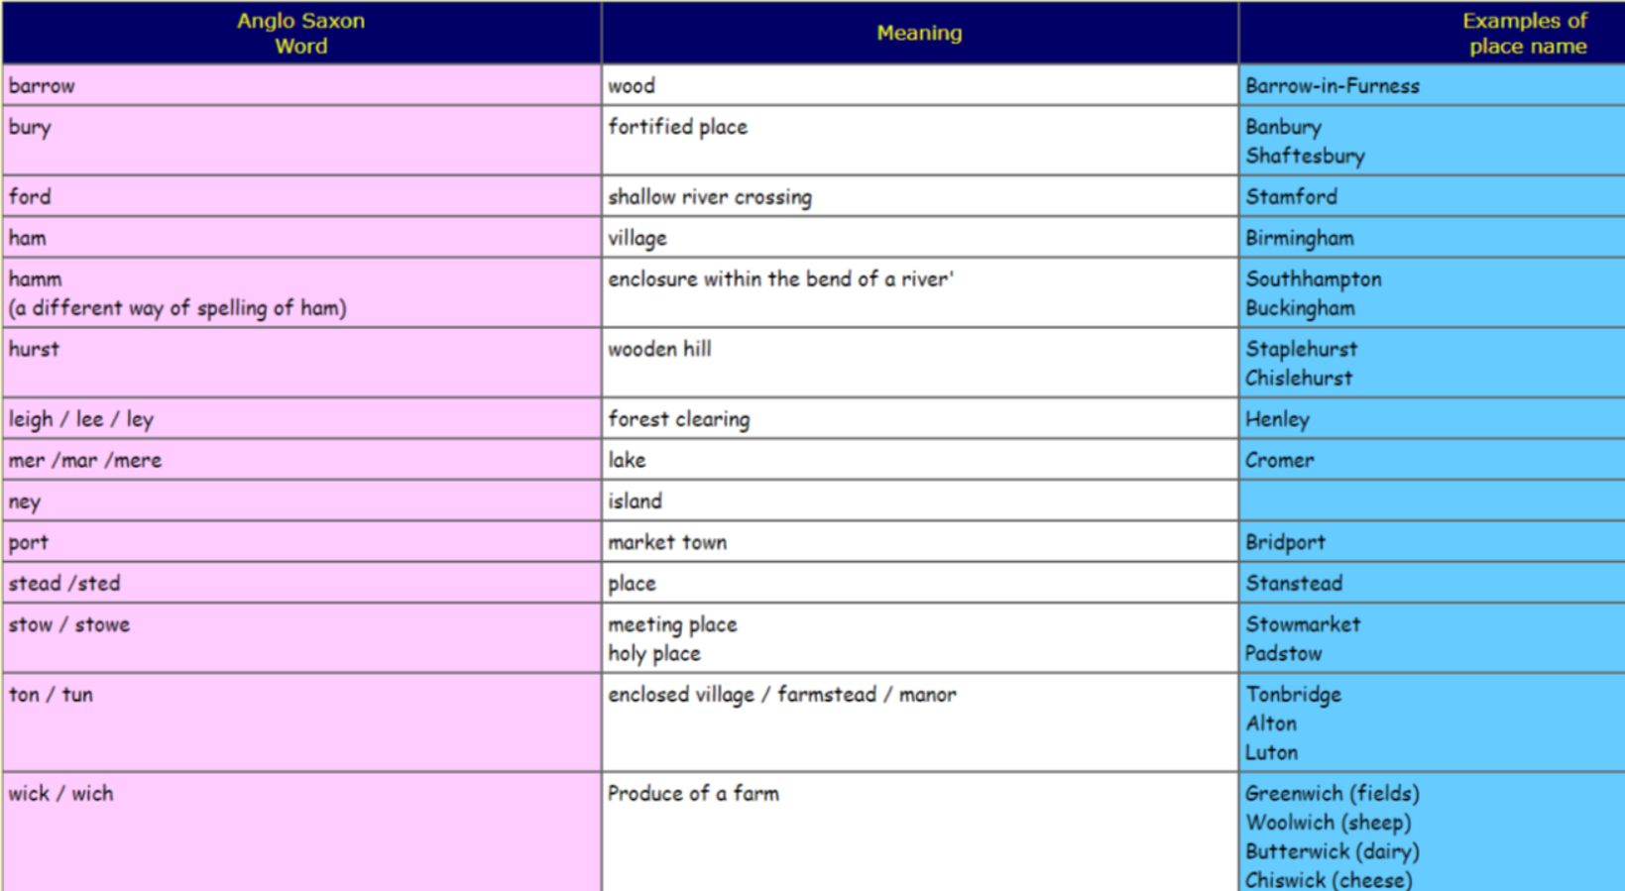
When the Vikings came to Britain, they named some of the places too. This is how we know where the Vikings were – they left the place names behind.
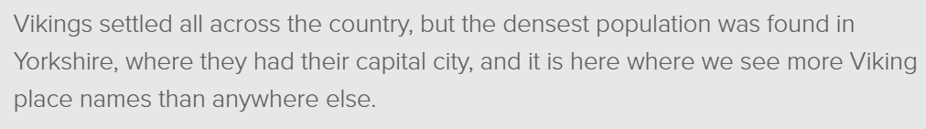
Look at the table below. Some of the endings of the Viking place names give the places a meaning.

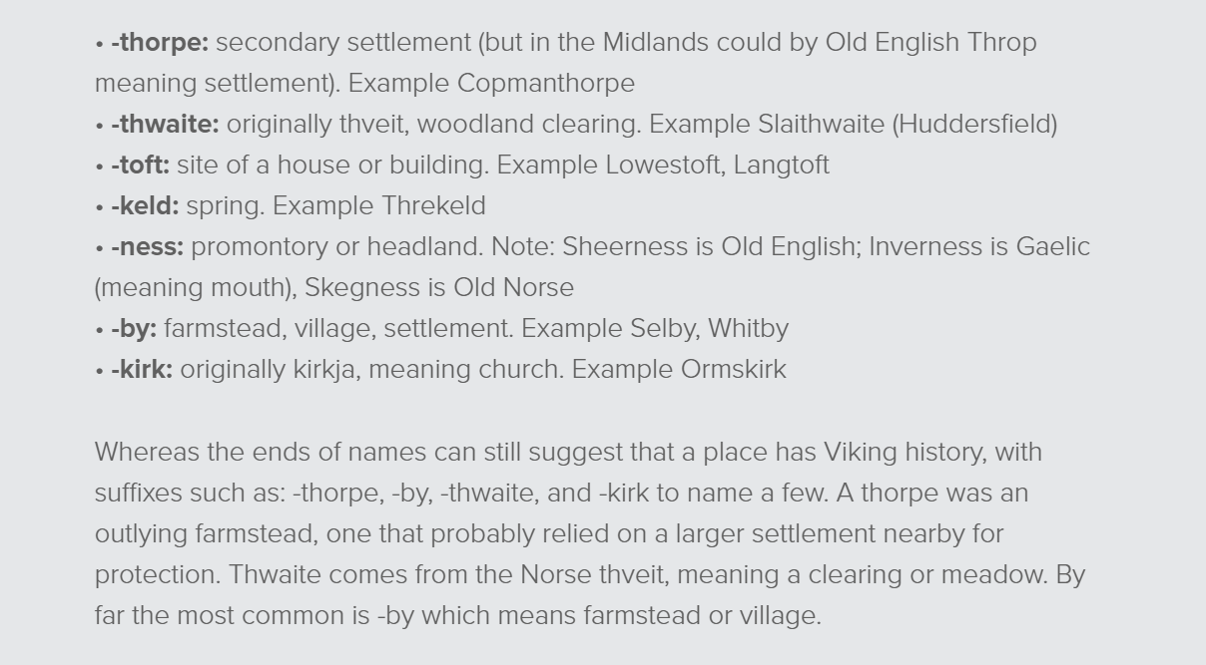

Your Task
Have a look at the map of the area around York. York is the main place where the Vikings settled. Identify place names around that area that you think the Vikings or Anglo-Saxons named. Look for the endings of words mentioned in the table above.
e.g. Bishopthorpe - Thorpe means settlement.

How many places can you find? What does the place name mean?

