Viking Traders and Explorers – Geography
We know that the Vikings came to Britain, but where else did they go? What did they trade whilst they were exploring?
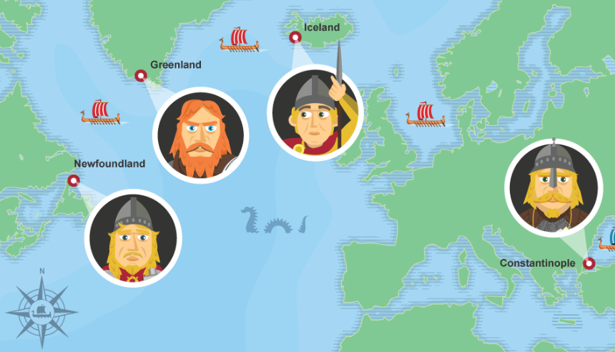

Use the following information and website to find out all about the places that they went to and the things that they traded.
Create a non-chronological report which includes a world map with key places highlighted and key facts about what they traded and when.

Your report can be hand written or made on the computer. You could make a powerpoint presentation if you like.
Remember to include:
- An eye-catching heading in a large font.
- An introductory paragraph.
- Text split up into paragraphs and each paragraph on a different aspect of the subject.
- Sub-headings for each paragraph. (Questions make great sub-headings)
- Usually written in present tense.
- Pictures of the subject.

Website:
https://www.bbc.co.uk/bitesize/topics/ztyr9j6/articles/zw3qmp3
