Friday 12th June
Writing our own poem

Now that you have got your own word banks, similes and metaphors to describe a dragon, you are going to put them together to create your own poem.
Look at the picture again and focus on one feature at a time.
Use these questions to help you create a verse for your poem.
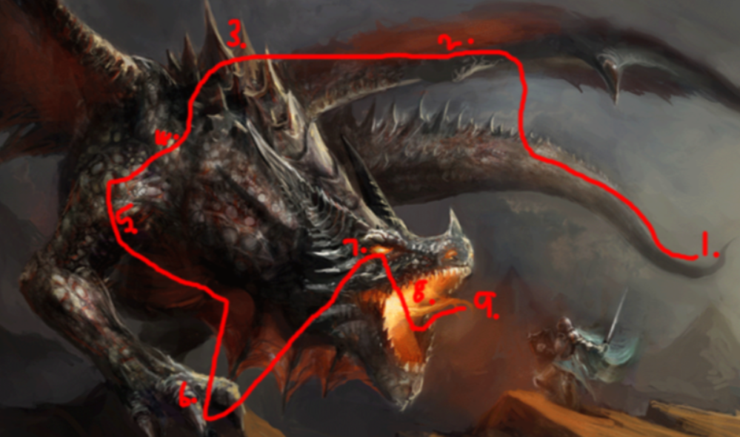
- What is it?
- What does it do?
- How does it do it?
- What does it compare to?
(simile or metaphor)

Example

Its pointy-tipped tail
thrashes in fury
like an uncontrollable caged cat.

Bat-like, whipping wings
flap intensely
as fast as lightening
striking its prey.

The spikey spine
is a rough terrain
of mountains
zigzagging like
torturous teeth.

Your turn! Have a go at writing your own poem. Use this example and Xfilious.

Notice the use of alliteration too! (The same sound repeated.)
Can you use alliteration in your poem?

