Xfilious
Its scarlet eyes
Scan the
Pitch undergrowth,
Like crystal flames
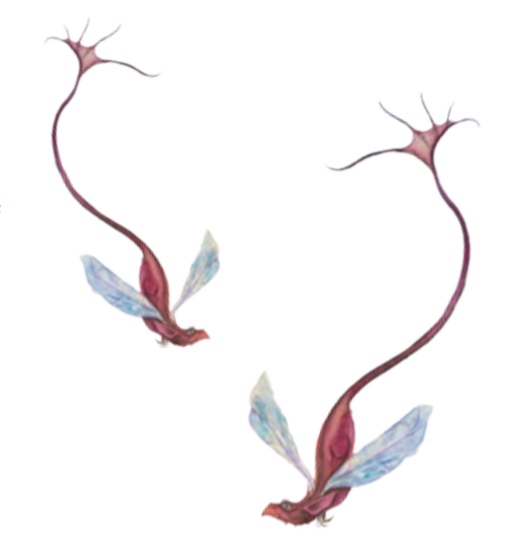
Flickering, curved like
A curious cave,
Possessed by mysteries.

Its jagged jaws
Crawl, grinding
Broken bones,
Shredding fascinating flesh!

Dagger teeth
Drip with venom
Drizzling disaster
Every stormy step it takes.

Scarred scales
Are like dreaded diamonds
Flexing, glistening in the
Moonlight,
Like shattered
Mirrors of misery.

Curved talons grip,
Illuminated menacingly
By stunned stars -
Crafted by brutal blades.

Scalpel spines slope,
Zigzagging wildly
Like a staircase of
Shark fins.

Crouching
At the monstrous mouth
Of its lethal lair,
Xfilious
Glares
Into the petrified eyes
Of darkness and
Whispers words of warning...

