Thursday 11th June
Adding fraction Reasoning challenges
Re-cap – complete these to see what you remember from earlier in the week.
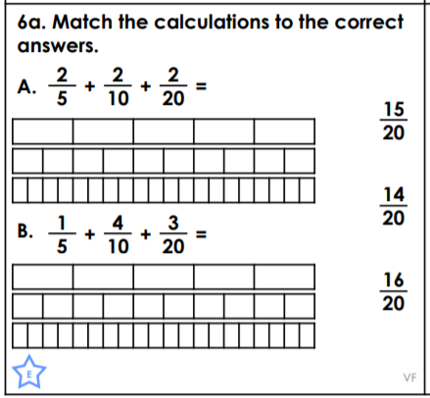
Example of reasoning
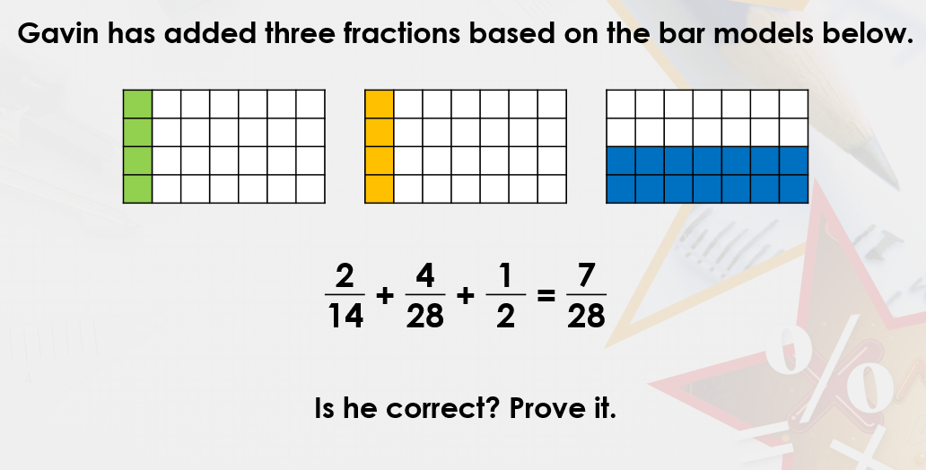
Click here to watch the video explanation
https://www.loom.com/share/bdf4f6407566491f98044160ffd0eb93
Make the denominators the same. In this case, it will be 28. Then add them together.
$$\frac{2}{14}=\frac{4}{28}$$
$$\frac{4}{28}$$

$$\frac{1}{2}=\frac{14}{28}$$

Add them together
$$\frac{4}{28}+\frac{4}{28}+\frac{14}{28}=\frac{22}{28}$$

(Simplify the answer if you can = $\frac{11}{14}$)

Your Turn – have a go at these reasoning questions
