Tuesday 9th June
Adding fractions with different denominators
Yesterday, we added fractions with the same denominators.
How do we add fractions when the denominators are different?
John
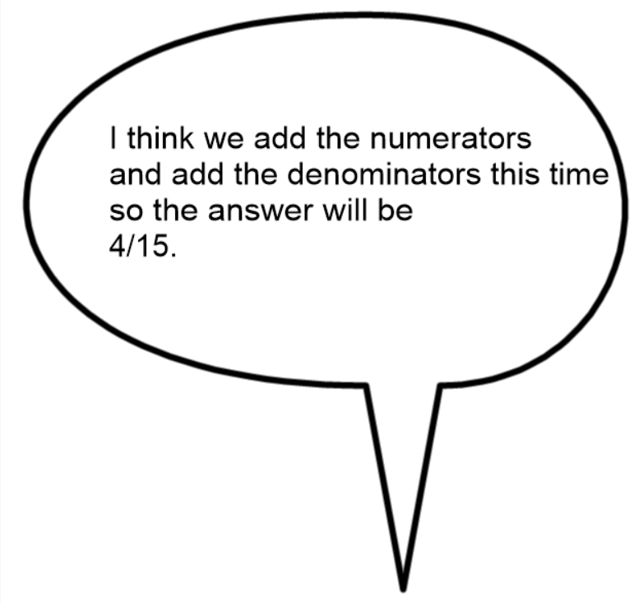

Do you agree with John? If not, why not?

If John is not correct, then how do we add fractions with different denominators?

$$\frac{1}{5}+\frac{3}{10}=$$

Because the denominators are different, we need to make them the same. We need to find a common multiple.
10 is a multiple of 5 and 10, so we can use 10 as the denominator.

Change $\frac{1}{5}$ into 10ths.
Remember that whatever you do to the bottom, you must do to the top.
$$\frac{1}{5}=\frac{2}{10}$$
Now we can add the fractions together easily.
$$\frac{2}{10}+\frac{3}{10}=\frac{5}{10}$$
$$\frac{5}{10}can be simplified to 1/2$$
+ =

See video here to explain it more clearly https://www.loom.com/share/0c79f531acb145b7960dd716bf3bd0cd

Your turn – add these fractions with different denominators.
- $\frac{1}{8}+\frac{1}{2}=$
- $\frac{2}{5}+\frac{2}{15}=$
- $\frac{8}{9}+\frac{1}{3}=$
- $\frac{1}{7}+\frac{3}{14}=$
- $\frac{2}{3}+\frac{4}{15}=$
- $\frac{1}{4}+\frac{4}{12}=$
Challenge
