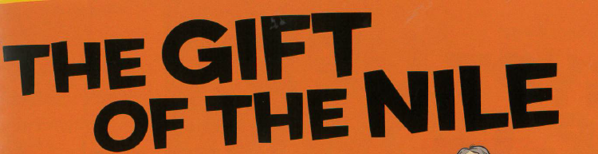
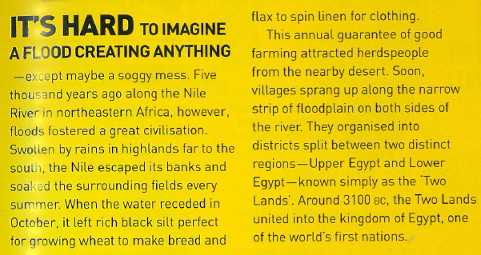
What happened when rains fell in the highlands?
_______________________________________________________________________________________
_______________________________________________________________________________________
Describe what happened when the water receded.
_______________________________________________________________________________________
_______________________________________________________________________________________
_______________________________________________________________________________________
Why did people leave the desert?
_______________________________________________________________________________________
How do we know that people began to live next to the Nile?
_______________________________________________________________________________________
_______________________________________________________________________________________
What are the Two Lands of Egypt?
_______________________________________________________________________________________
When did the two regions become one?
_______________________________________________________________________________________

What are the 5 other gifts of the Nile?
- ___________________________________
- ___________________________________
- ___________________________________
- ___________________________________
- ___________________________________
Papyrus

Seasons

Religious Outlook
Bricks

Transportation

