Monday 8th June
Adding fractions with the same denominator – revision
Can you remember how to add fractions when the denominators are the same?
Rosie thinks it’s easy to add fractions. Do you agree with her answer? Explain why?
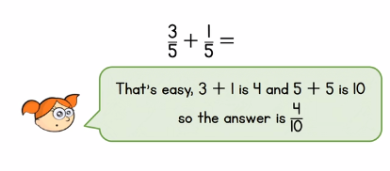

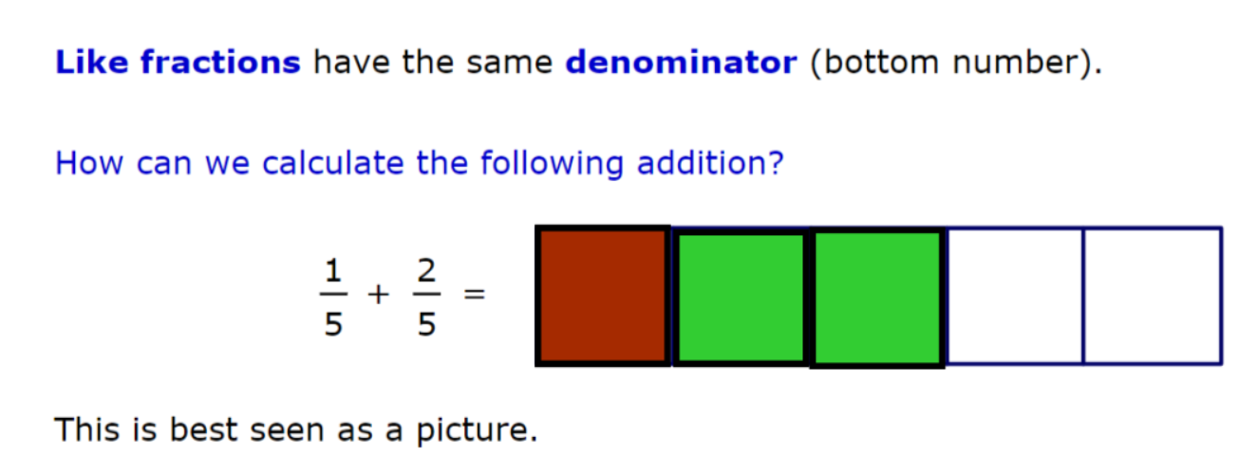

The denominators are the same, so just add the numerators!
$\frac{1}{5}$ + $\frac{2}{5}$ = $\frac{3}{5}$

Your turn
- $\frac{1}{3}+\frac{1}{3}=$
- $\frac{1}{7}+\frac{1}{7}=$
- $\frac{1}{5}+\frac{3}{5}=$
- $\frac{5}{9}+\frac{2}{9}=$
What happens when your answer is greater than 1?
This time, write your answers as a mixed number.
Example
$\frac{5}{8}+\frac{4}{8}=\frac{9}{8}$ = 1$\frac{1}{8}$

9 divided by 8 is 1 and $\frac{1}{8}left over$
Your turn
- $\frac{4}{8}+\frac{7}{8}=$
- $\frac{2}{3}+\frac{2}{3}=$
- $\frac{7}{11}+\frac{6}{11}=$
- $\frac{9}{12}+\frac{5}{12}=$
- $\frac{13}{15}+\frac{8}{15}=$
- $\frac{7}{5}+\frac{6}{5}=$

