Week 1
We hope you all had a great half term!
Our topic this half term is Minibeasts, we are excited to learn new facts about different minibeasts and their habitats.

Monday 8th June
English
Watch the Story of The cautious caterpillar.
https://youtu.be/-zcqzXFG_ng
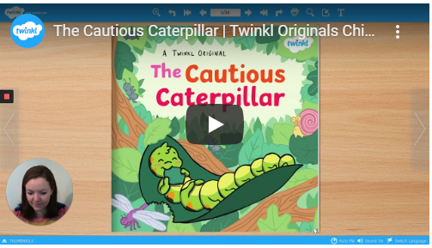
Word of the day: Cautious (to be careful)

Maths
Can you solve the minibeast additions?
Topic
Go for a walk outside, maybe in your garden or to the local woods. What minibeasts can you find?
Physical
Practice the incy wincy spider rhyme. Can you make up some actions to go with it?
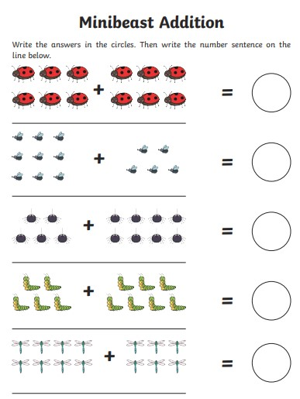

Tuesday 9th June
English
Can you retell the story of the curious caterpillar to a grown up?
Word of the day: Tiring (needing a rest)
Maths
Can you solve the minibeasts subtractions?
Science
Watch the video of butterfly life cycle.
https://youtu.be/3o_nE1X014U
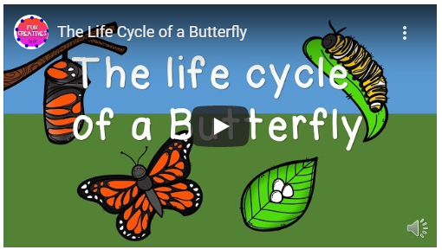

Have a go at ordering the life cycle of a butterfly by drawing the different stages or use the template provided.
Physical
Can you move like the different minibeasts?
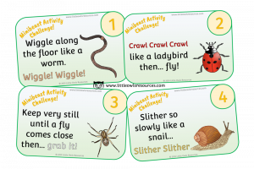
Independent
Choose your own clothes and dress independently.

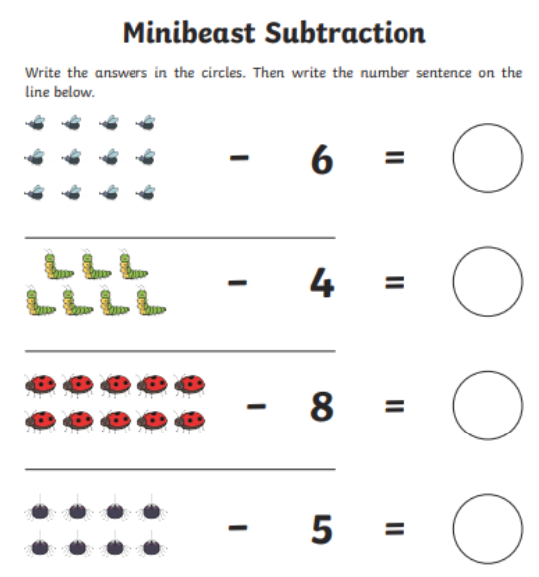

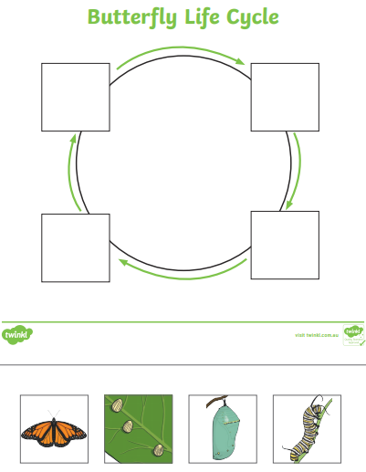

Wednesday 10th June
English
Can you write a list of all the minibeasts that the Curious Caterpillar met?
Word of the day: become(starting to be)
Maths
Can you double the butterfly spots?
Topic
Have a go at making a minibeast model. You could use playdough or junk modelling such as boxes and yogurt pots.
Physical
See if you can follow the yoga moves
https://youtu.be/pT-s1-phgxs
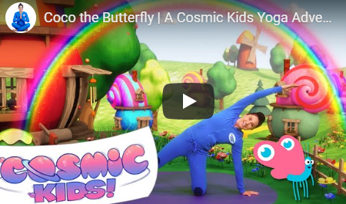

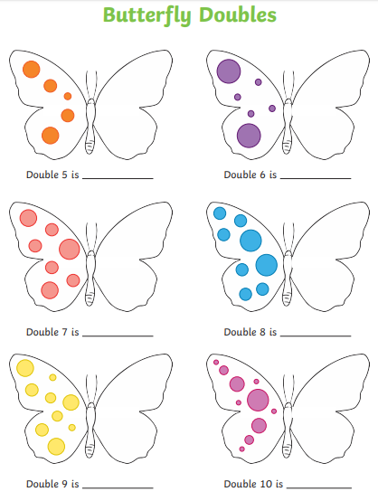

Thursday 11th June
English
Can you write a sentence about your favourite minbeast?
Word of the day: Plenty (more than enough)
Maths
Can you share the bees out evenly? You could draw them out if you do not have access to a printer!
Science
Find out why spiders don’t get stuck to their webs by completing the sticky web experiment.
Physical (fine motor)
Cut circles out of paper and label them from 1-10. Using clothes pegs give each spider the correct amount of legs.

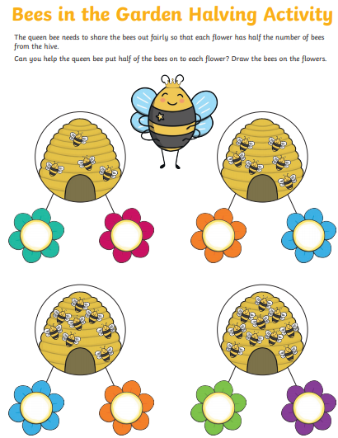

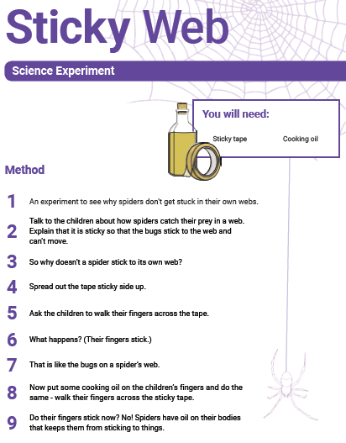

Friday 12th June
English
The curious caterpillar turned into a butterfly. If you could turn into anything what would it be and why?
Write a sentence or send a video explaining.
Word of the day: Explore (to find out more about something)
Maths
Go on a walk and record how many minibeasts you find.
For example:
Spider 4
bee 6
worms 3
Topic
Have a go at creating some minibeast pebbles.
