Friday 12th June
Tangrams – problem solving
A tangram is a Chinese geometrical puzzle consisting of a square cut into seven pieces that can be arranged to make various other shapes.
Today, you are going to see if you can use the pieces to create different shape outlines.
There is an electronic version of this activity here:
https://nrich.maths.org/14169
or you can print the pieces of the tangram below and cut them out to have a go at rearranging them into the different shapes.

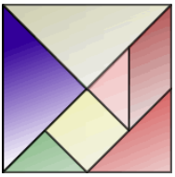

Start by seeing if you can make this shape:

Then
or

What about these?

There are lots of different levels to follow and try on Nrich website. (use the link above and follow the links through the World of Tan.
What other shapes can you make with your paper shapes?
Can you make a duck? A boat? A flower?
If you can, take a pic and upload it for us to see. Have fun!

