Ancient Greek Olympics

Last week, you started researching the Ancient Greek Olympics and compared it to the modern Olympics, which still takes place.

Write down everything you can remember about the two Olympic movements – think about what is the same and different about them!
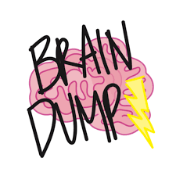

Now, watch these videos about the Olympic games. Write down notes about what you have learnt:
https://www.youtube.com/watch?time_continue=3&v=jA6Y7gG3OLs&feature=emb_logo
https://www.youtube.com/watch?time_continue=2&v=z9lFwCDuj38&feature=emb_logo

Follow the link to complete the Kahoot quiz and what you have just watched, and remember to share your score with the adults! Have fun!
https://kahoot.it/challenge/08759214?challenge-id=62bac98c-2643-4025-b5f9-ecc7f8137240_1594201603488

Game PIN: 08759214
Now, design a poster advertising the Ancient Greek Olympics! Remember to include details about:
- Where it takes place
- Who is invited to attend
- Which events will be happening

Your job is to persuade the people who see your poster that they should go! Be creative, colourful and eye-catching!

Below are some examples of other posters advertising events, but remember to include all the important information!
