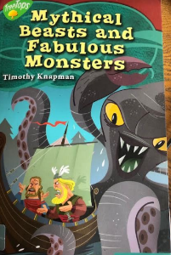**Friday 10th July 2020**

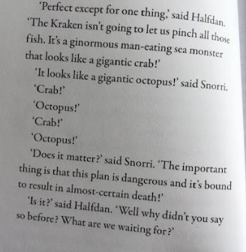

**Here you are introduced to the monster, The Kraken. Draw what you read from the given description.**