Friday 10th July
Boxing up and planning your own story

You have been given a boxed up version of our WAGOLL – How to Train a Dragon. You will need to imitate that story when writing your own version of it next week.
Today, you will start to box up a plan of your own version.
When you box up, you don’t need to write the whole thing out – you just need to make notes, showing how you would change the original to make it your own.
See the below example of boxing up and changing key things:
https://www.loom.com/share/52a967057c824a5f813fa57e0f97a79a

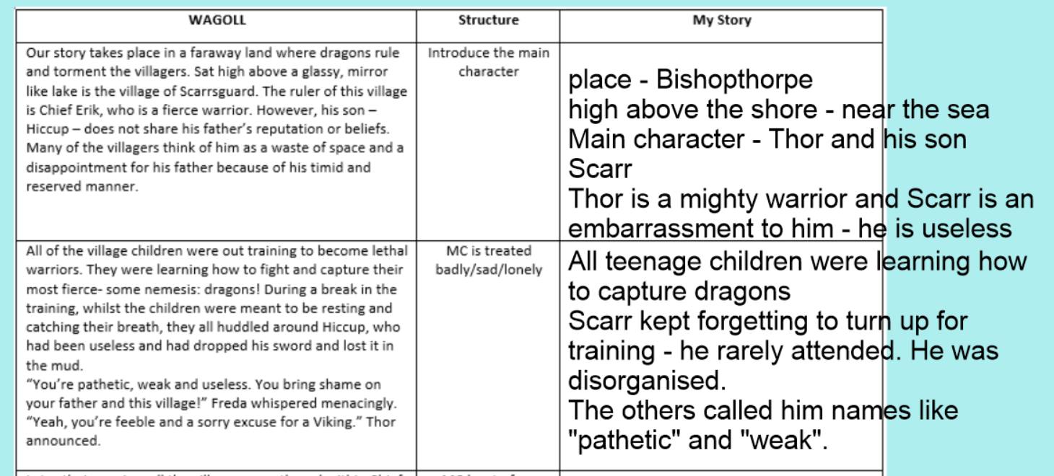
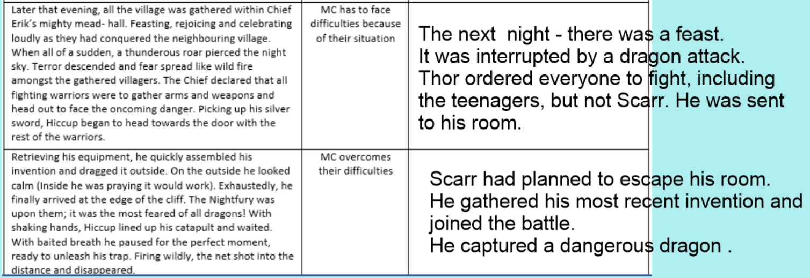
Now have a go at creating your own story plan on the boxing up grid provided.

