Friday 17th July 2020
Finish off your comic strip. Now publish it (write it up neater and address any errors) and please use today’s lesson to learn and perform your comic strip!
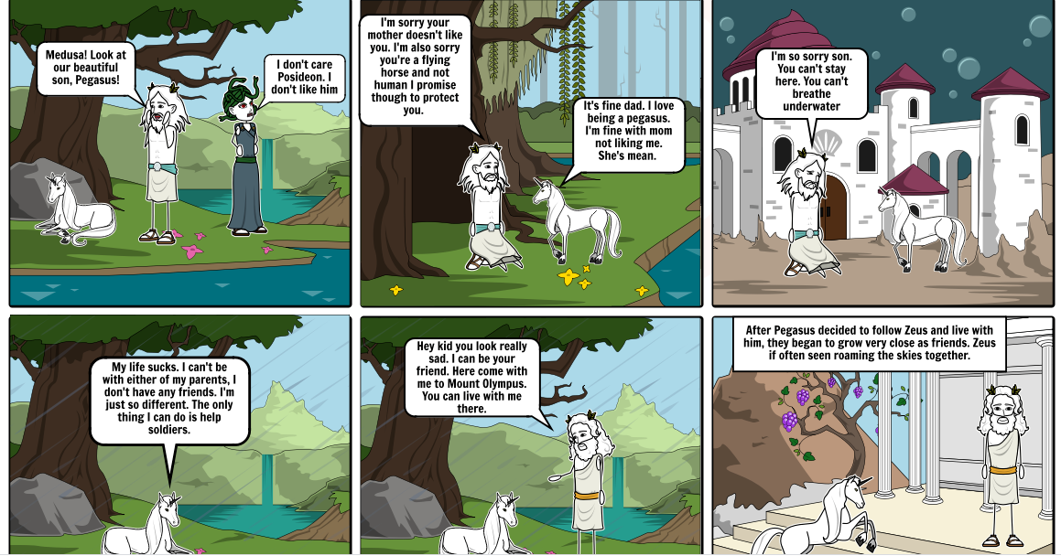
Videos would be great to see!

