Friday 17th July
Maths Games

As it’s nearly the summer holidays and you have completed your Maths revision this week, it’s time to have fun with some maths games.
Below are links to several games that you can play on line or with a partner in person.
- Matching pairs – Times tables (You can choose which tables to include)
https://nrich.maths.org/1252
If you can’t play online, why not create your own times table cards and play pairs with a friend?
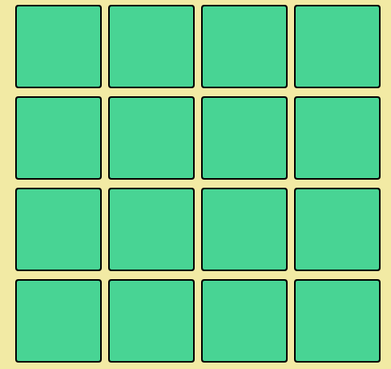

- Matching pairs with fractions, decimals and percentages (level 1)
https://nrich.maths.org/1249

- First connect three
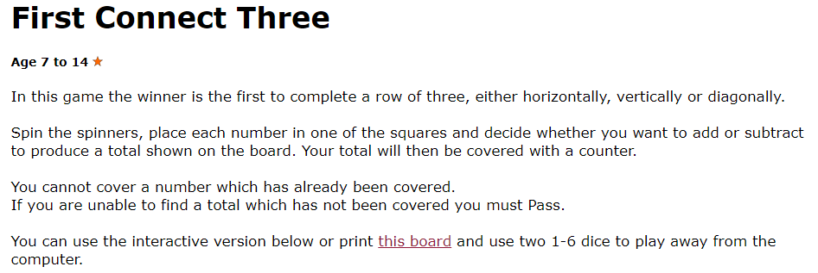
https://nrich.maths.org/5865

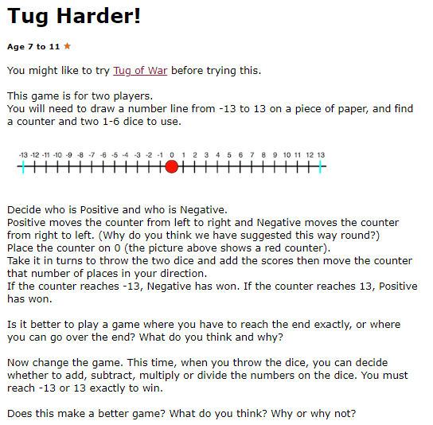

https://nrich.maths.org/5898

- 9 hole light Golf
Can you convince yourself that it is possible to reach every possible arrangement of lights?
We think this 3x3 version of the game is often strangely harder than the 5x5 version, which can be found here. Why might that be true?
https://nrich.maths.org/7383

- Stop or Dare

Age 7 to 16

A game for two or three players. You will just need a pack of cards.
Shuffle the pack and place it face down. Set a target score for the game, for example 100.

The first player turns over the top card and continues turning over cards, adding together the value of each card, until they decide to stop. Jacks score 11 and Queens score 12.
When the player stops, the total is recorded as their score.
However, if an Ace or a King is turned over, no points are scored at all, and the turn is finished.
The second player then starts turning over cards in the same way.
Players take turns until someone reaches the target score. This player is the winner.
If the cards are all turned over before the target is reached, just reshuffle the pack and continue.
Play the game a few times.
Can you develop any strategies to increase your chance of winning?
https://nrich.maths.org/1193

