Friday 17th July
Editing and re-drafting

Congratulations for completing your story! You have done a great job.
As with all good writers, now that you have finished writing your story, you are going to read it through, from start to finish, and edit/ improve it.
Watch this video of Tom Palmer editing his writing before you edit yours. Think about things you could add, take away and replace.
https://www.youtube.com/watch?v=CUScPnDwzPU&feature=emb_title
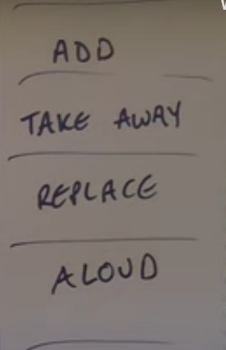
Remember to read your work aloud as it will help you to recognise where the commas and full stops need to be. You need the commas for clarity so that your work makes sense.
When you want to replace a word, remember to use a thesaurus (there are plenty on line ).

Your turn – please edit your writing in a different colour so that we can see what you have replaced/ changed.
If you are using word, you could use the “Review button” and then “track changes”. This will show us what you have deleted and replaced it with.
Have a go!

